BA 706 - Applied Analytic Modelling

# 

# 

Predicting Bank Application Fraud

# 

Group 5

Rakeen Ahmed - 301307050

Faiza Zahin - 301318801

Raghav Gupta - 301272406

Drashti Lakhani - 301241918

# Table of Contents

**Table of Contents 2**

**Introduction and Objective 2**

**Data Setup and Exploration 3**

Procedure 3

Variables discussion 3

Target variable 3

Rejected variable 4

Binary variable 4

Missing Data 4

Skewed Data 5

StatExplore 6

Data Oversampling 7

Data Partitioning: 50:50 9

**Decision Trees 9**

Maximal Tree 11

ASE Tree 13

Misclassification Tree: 14

ASE 3-Branch Tree 14

ASE Tree 3B Treated 17

Model Comparison: Trees 18

**Data Manipulation 19**

**Regressions 27**

Full Regression 27

Forward Regression 28

Backward Regression 30

Stepwise regression 32

Polynomial regression 34

**Neural Networks 36**

Decision Trees Neural Networks 36

ASE Neural Network 36

Misclassification Neural Network 38

ASE 3B Neural Network 38

Summary: Decision Tree NN 39

Forward Regression Neural Networks 39

3 Hidden Unit Neural Network (100 iterations) 40

4 Hidden Unit Neural Network (100 iterations) 40

5 Hidden Unit Neural Network (100 iterations) 41

6 Hidden Unit Neural Network (100 iterations) 41

Polynomial Regression Neural Networks 42

3 Hidden Unit Neural Network (100 iterations) 44

4 Hidden Unit Neural Network (100 iterations) 44

5 Hidden Unit Neural Network (100 iterations) 45

6 Hidden Unit Neural Network (100 iterations) 45

Data Modification Neural Network 46

Impute Neural Network 46

Cap and Floor Neural Network 48

Transform Neural Network 49

Recode Class Neural Network 51

Other Neural Networks 53

3 Hidden Unit Neural Networks 55

4 Hidden Unit Neural Networks 55

5 Hidden Unit Neural Networks 56

6 Hidden Unit Neural Networks 56

3 Hidden Unit Neural Networks 57

4 Hidden Unit Neural Networks 57

5 Hidden Unit Neural Networks 57

6 Hidden Unit Neural Networks 58

**Gradient Boosting 58**

Gradient Boosting 100 61

Gradient Boosting 500 62

Gradient Boosting 800 65

**Principal Component Analysis 66**

ASE Tree 3B PCA 68

Cap & Floor NN PCA 68

**Model Comparison 69**

**Recommendations and Key Findings 74**

Models to Use 74

Key Features 74

Features to monitor 74

**Conclusion 75**

**References 75**

**Appendix 75**

Full Model Screenshot 75

# 

# 

# Introduction and Objective

New Account Fraud is a major problem in the banking industry, and is one of the most common types of bank account fraud, accounting for 23% of all bank account frauds. It involves the creation of a new bank account using false or stolen personal information by the fraudster, which is then onboarded by the bank as a legitimate account. The account can then be used for various fraudulent activities such as money laundering, illegal transactions, credit card fraud, etc. For our project, the dataset obtained from Kaggle.com contains 1 million instances of synthetic bank account opening applications with 31 variables and a binary label indicating whether they were deemed fraudulent.

The objective of our project is to understand the key features that can predict fraudulent account applications from the dataset, and train machine learning models that can accurately predict fraudulent applications so that such applications can be flagged and investigated before they are approved by the bank. For this project, we will be training three types of models - Decision Trees, Logistic Regressions, and Neural Networks. The performance criteria for evaluating the accuracy of models will be Average Squared Error.

# Data Setup and Exploration

## Procedure

Kaggle Dataset->SAS Enterprise Miner ->File Import Node-> Import .csv file from H: Drive

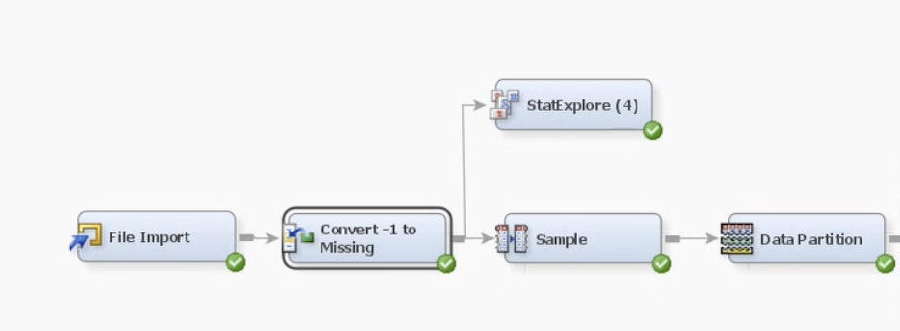

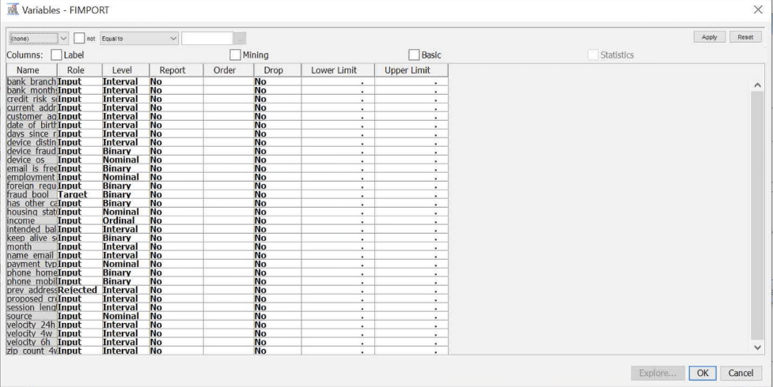

## Variables discussion

### Target variable

We have chosen **fraud_bool** as our target variable as we are predicting bank fraud cases. It is of Binary level i.e.1 & 0, where 1 implies fraud.

### Rejected variable

We have chosen **prev_address_months_count** as our rejected variable because all the missing values in this variable have been modified as -1 instead of 0. It is our redundant variable.

### Binary variable

For our model, we have chosen some of our variables as binary such as device_fraud_count, email_is_free, phone_home_valid, phone_mobile_valid, has_other_cards, foreign_request, keep_alive_session.

## Missing Data

The dataset chosen from Kaggle had some disclaimers. One of which was, all missing values across variables have been modified as -1 instead of 0. Complications arose from this status quo as SAS Enterprise Miner needed to recognize -1 as genuinely missing. Besides that, -1 would have affected all models.

The screenshot below is illustrating one of the variables, prev_address_months_count. In the histogram we can see, that -1 has the highest frequency.

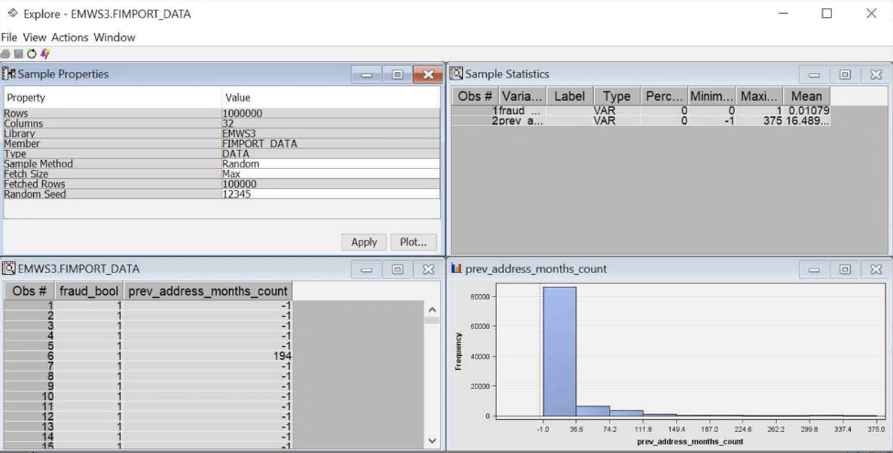

Therefore, as step 2 of our project, we added a Replacement node, to identify -1 as 0. In short, place the missings. The screenshot below shows all the successfully replaced values. For example- bank_months_count had 253635 rows replaced.

Since the values for days_since_request variables were concentrated mostly around 0 to 1, we created a flag for this variable using the replacement node. We set a lower limit of 0.99999 and an upper limit of 1.00001.

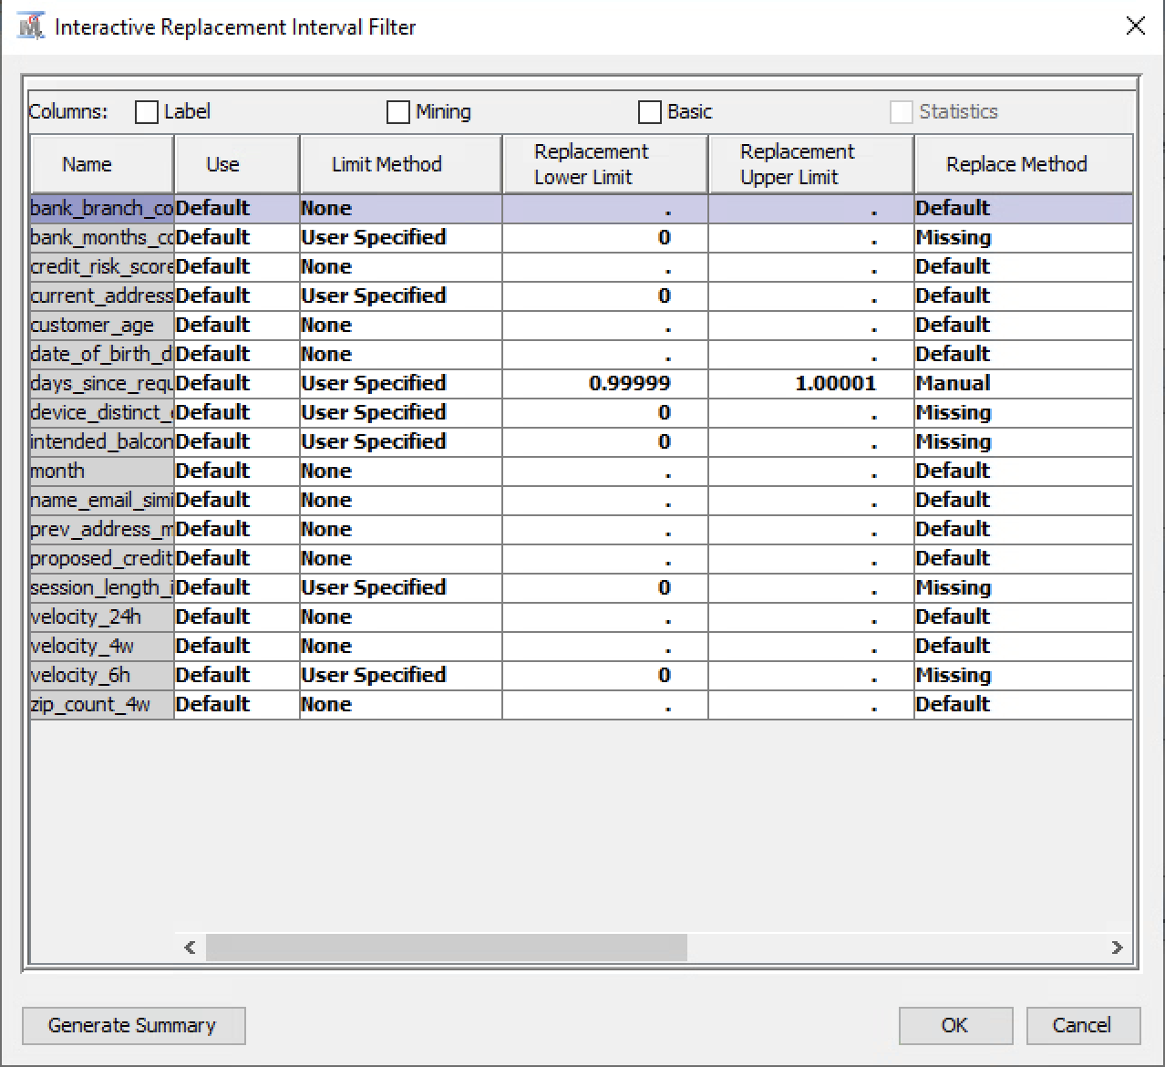

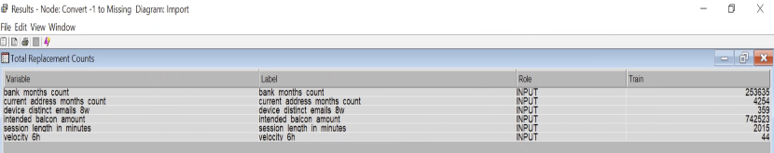

## Skewed Data

While also exploring the dataset, preliminary perusal showed skewness in multiple variables. The cut-off for skew for this project has been set at -1 to 1.

Upon further inquiry, all the statistics for the interval inputs were brought to light. As per the table below, the variables days_since_request, bank_branch_count_8w, session_length_in_minutes, device_distinct, etc. are heavily skewed. For now, we have only treated days_since_request using the flag in the replacement node. But, more will be done in the latter parts of the project.

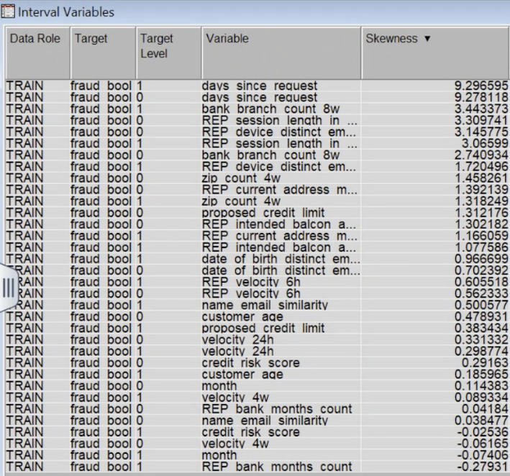

### 

## StatExplore

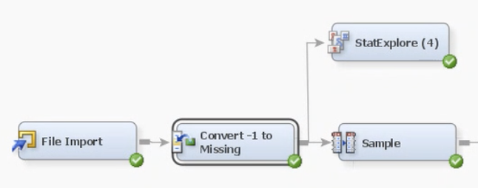

The screenshot below depicts the results of all the variables post the replacement node via a StatExplore node. 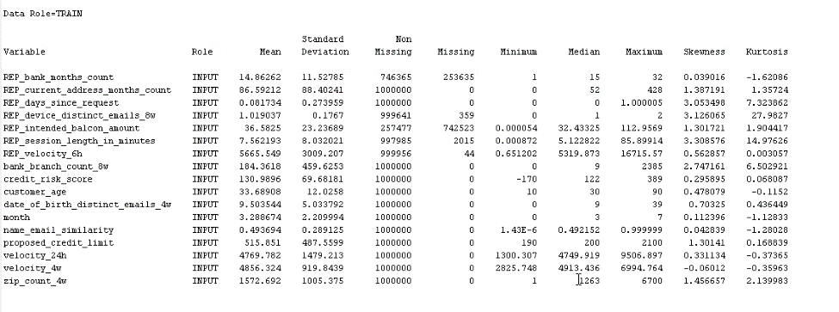

The first few variables starting with the prefix REP, refer to the ones which have been modified in the previous step, the replacement node. We used the node to replace missing values and flag values. For example, REP_device_distinct_emails_8w has 359 missing values in the dataset and 999641 non-missings. Similarly, all the variables which have undergone replacement have their missing and non-missing listed in the 3rd and 4th columns with the REP prefixes.

We can refer to the means and standard deviations of all the inputs from the first 2 columns. For instance, the average credit risk score for all the clients in the bank is around 130.98, with a standard deviation of 69.6 bps on both the positive and negative scales.

Minimum, Median, and Maximum values give an overall view of the data. The minimum or youngest customer is 10 years old, the median is 30 years old and the maximum is 90 years old at this bank. Lastly, we can also view the skew for each input in this output panel too.

## Data Oversampling

The dataset we are working with has Bank Account Fraud data points. Fraud is usually a rare event that is denoted by binary variables 0 and 1. In our dataset, the percentage of fraud is 1%, which is extremely low for data testing.

As depicted in the screenshot below, the accounts of ‘No Fraud’ severely outweigh the ‘Fraud’ events.

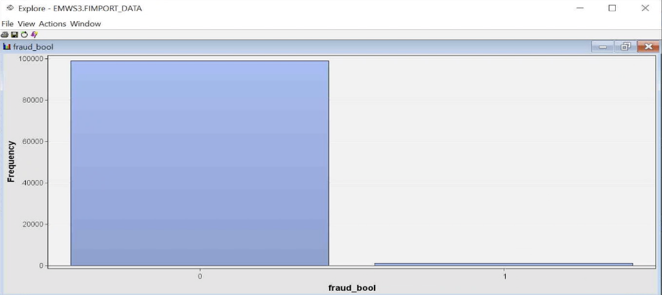

To bring a balance to the data, we are oversampling fraud events. We decided to keep a 50:50 ratio of 0 vs. 1. Using the Sample node in SAS, we adjusted the percentage by 100% and equaled it in the stratified criterion. The properties panel screenshot is below:

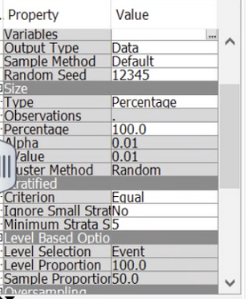

The screenshot below refers to the post-run results on the ‘Sample’ node. The initial dataset had almost 99% of non-fraud events. Whereas, after the successful run of the Sample node, the new percentages are 50:50 for fraud_bool( 0 vs. 1).

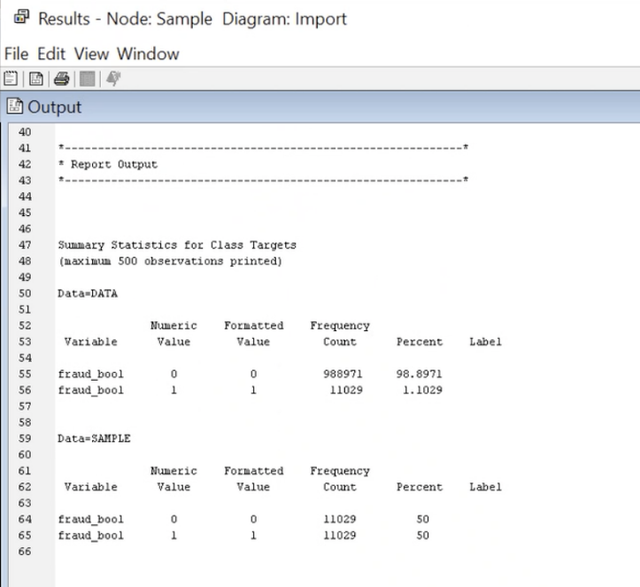

## 

## Data Partitioning: 50:50

Data partition is a procedure for best model prediction. We have split our data into two parts i.e., a 50:50 ratio for training and validation. Training data is used to fit each model and the validation model is a random sample that is used for model selection.

For data partition, we drag the data partition node from the sample tab and connect it to our data set, and as depicted in our screenshot we changed the properties of training and validation data set allocation to 50% in both.

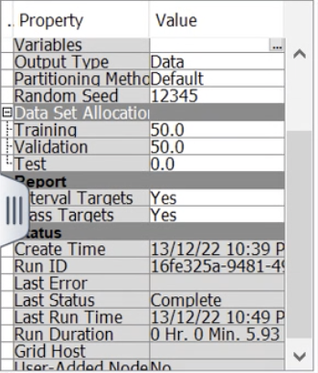

After making the necessary changes we ran our data partition node and viewed the results.

As per the results that can be seen in our screenshot, training data has been allocated 50:50 to 0 vs 1 and their frequency count is 5514 for each. Validation data has also been allocated 50:50 and their frequency count is 5515 for each.

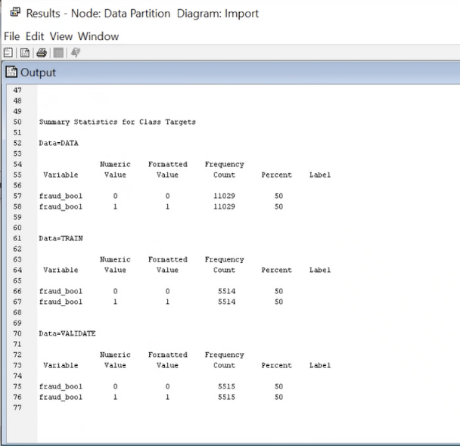

# Decision Trees

After partitioning our data, we continue with the data analysis and one of the most effective methods for predictive modeling is decision trees. A split search strategy is used to choose the inputs, and it eliminates any variables with p-values less than 0.7. Pruning makes decision trees less complex by limiting the variables in the final tree to those with p values greater than or equal to 1. The Root Node is the first split, while the Leaf Nodes are the last splits.

We have implemented four different decision trees for this project:

* Maximal Tree
* ASE Tree
* Misclassification Tree
* ASE 3B Tree

The screenshot of the Decision Trees is shown below.

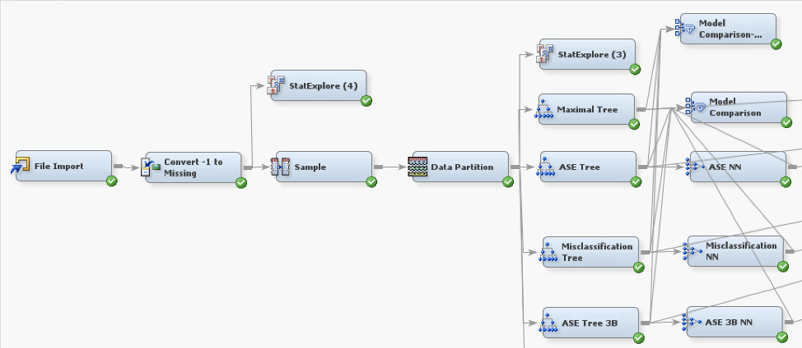

## Maximal Tree

Out of four different trees, we performed the Maximal Tree as our first decision tree. This tree is the largest statistically. This model has 55 leaves.

The root node is split using ‘housing_status’, followed by ‘device_os’. The 3rd splitting variable has changed with respect to each of the branches either to ‘has_other_cards’ or ‘replacement: current_address’. Screenshot below.

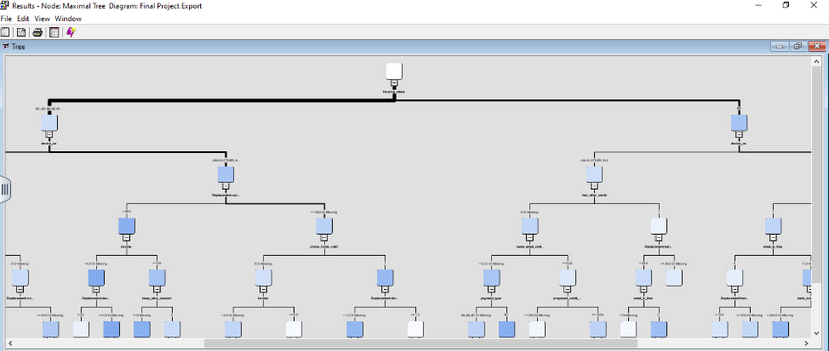

From the variables split, we see that more than 60% of the count has swayed to a housing_status besides BA. BA has a fraudulent validation rate of 77.27% compared to non-BA where fraudulent validation is 33.78%. Following BA, those with MAC, WINDOWS have the higher fraud validation rate of 85.55%. The 3rd split on this has_other cards, and those who have shown 0 or missing cards have a validation rate of 87.37%.

Having mentioned one area of the maximal tree, the ASE derived from the maximal tree was **0.173235** which is the highest among all the trees. The misclassification rate was 0.222615 for the maximal tree. The screenshot below shows the result of maximal tree.

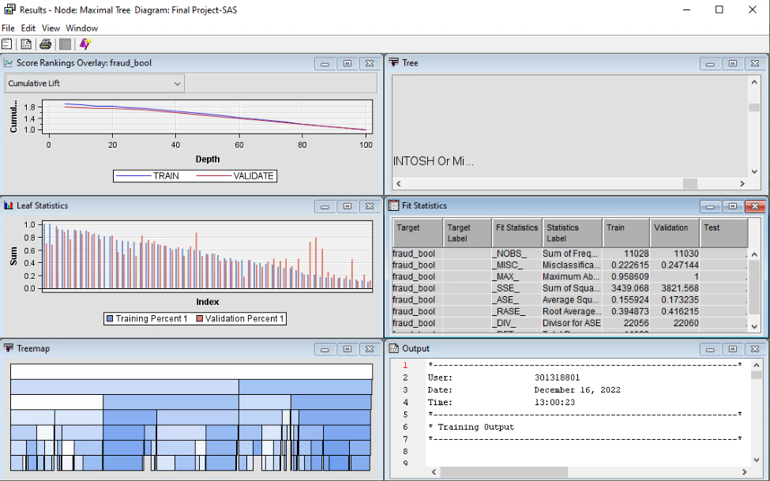

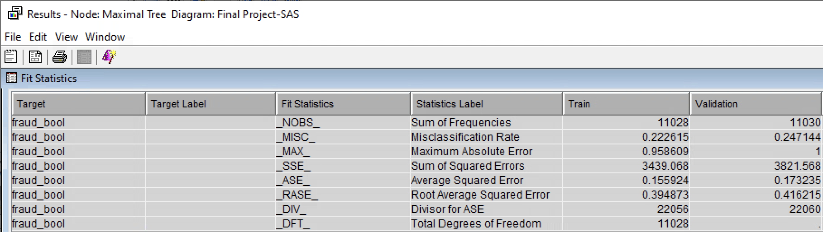

## ASE Tree

As expected the first 3 splits and validation rates remain the same, as optimal trees are produced by pruning branches from the bottom. We can refer to the tree map in the picture below. It is less dense than maximal. ASE tree contains 40 leaves which are lower than the maximal tree.

Given the reduction in the number of leaves, ASE has pruned the tree to its best. The ASE obtained from the ASE tree was **0.170573**, slightly lower than the Maximal Tree.

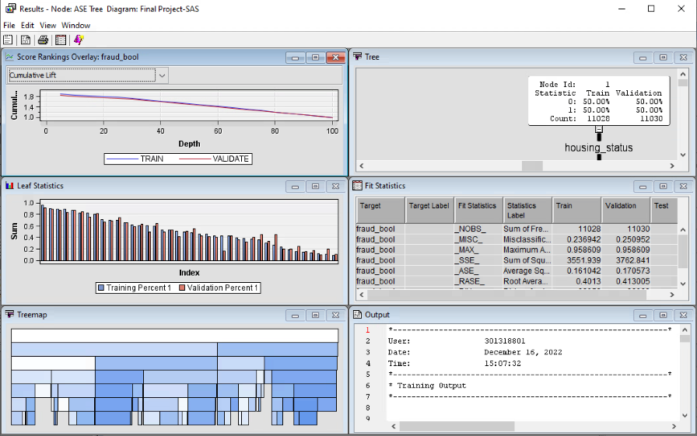

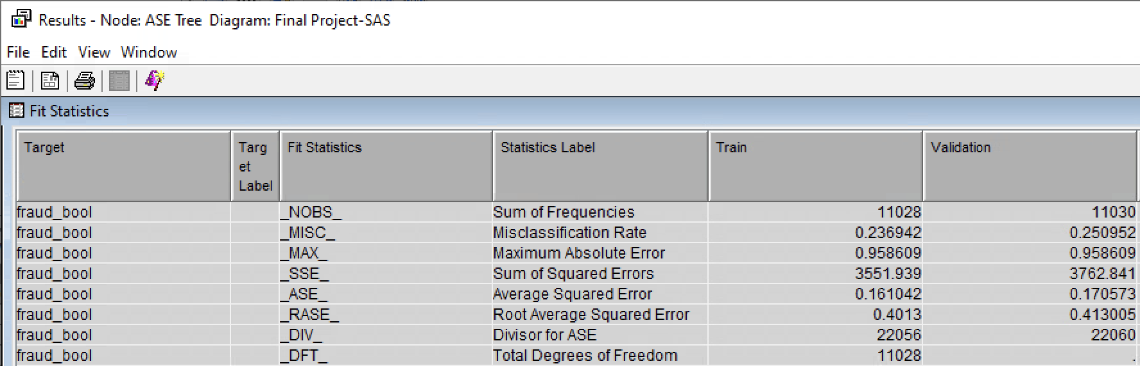

## Misclassification Tree:

This model contains 25 leaves altogether, which is much fewer than the preceding decision trees when compared to their total number of leaves. However, the misclassification tree's ASE is the highest of all the trees at **0.175272**. A screenshot of the maximal tree's outcome is shown below.

Even though pruning is an efficient way to reduce error rates, it can also do the opposite. Such is this tree, where the tree has been pruned to an extent that the error rates are rising. So far, this is the worst decision tree model.

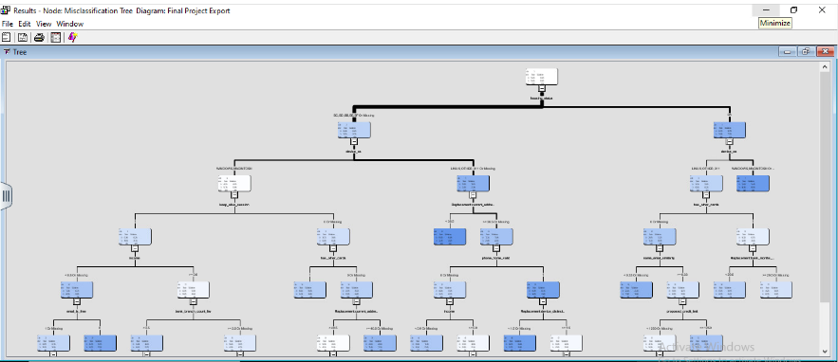

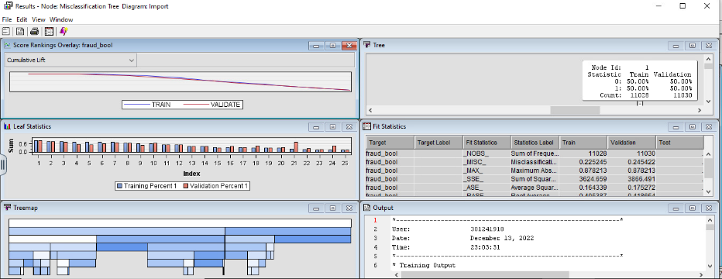

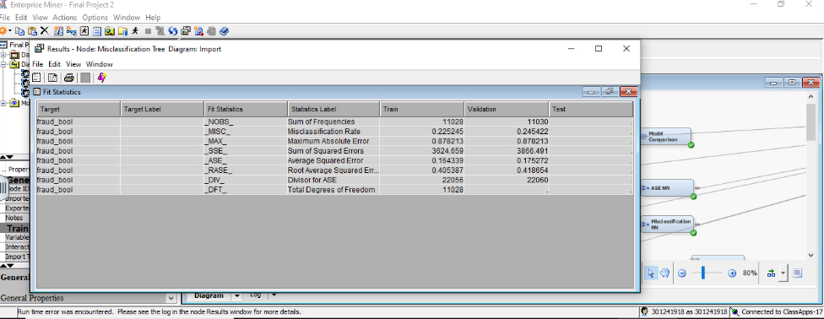

## ASE 3-Branch Tree

After exploring the 3 different trees, a 3-branch tree was deemed fit. However, due to the default function of SAS Enterprise Miner, we were getting 2 branches as main splits from the ‘Root Node’.

While deciding on the model to apply a 3-branch on, ASE 2-Branch Decision Tree proved best. The ASE derived from ASE Tree (2B) was 0.170573 which is the lowest among all the trees. So we created a 4th tree using ASE Tree (2B) as the base, only with 3 branches this time. Screenshot:

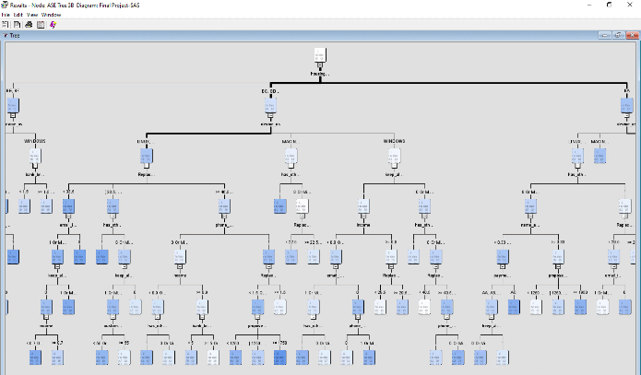

The number of leaves for this 3-branch tree is 52 and the ASE is 0.169517 which is the best so far and has been the expected result. 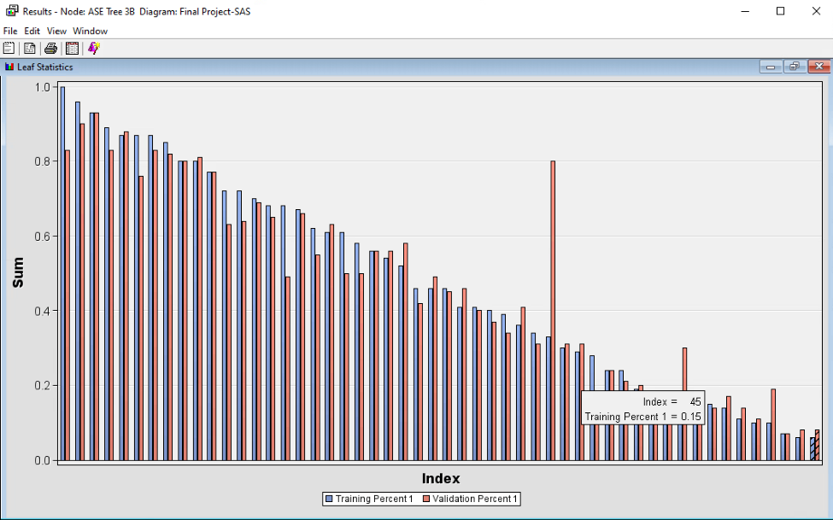

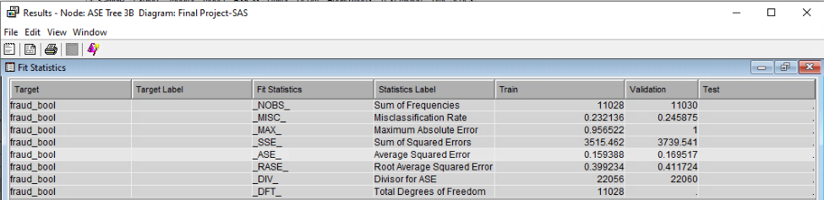

The splits on this tree give more insight than the trees above due to its 3 branch property. In comparison to the maximal tree BA fraudulent validation rate remains at 77.27%. However, we start to see changes in the next splits. Previously, MAC, WINDOWS & Missing split on BA derived an 85.55% fraudulent validation rate, now it has been split into 2 groups. Those using WINDOWS or Missing devices have a fraudulent validation rate of 86.22%. has_other _cards which are denoted as 0 or Missing have a fraudulent validation rate of 88.04% compared to maximal tree’s 87.37%.

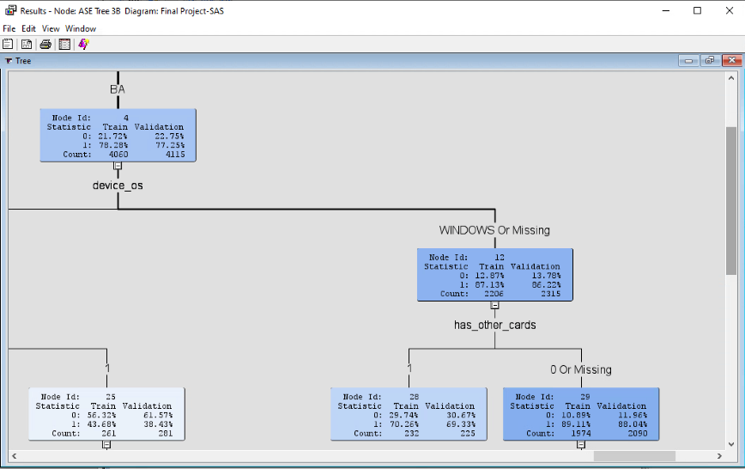

However, we further fine-tune our Trees with Neural Network nodes which will be covered in the Neural Network Section.

## ASE Tree 3B Treated

The 3 branch ASE was the best tree model developed so far. However, all the tree models were developed before treating the data (imputing missing variables, adjusting skews, etc). and we wanted to see whether the same tree built from the treated data would be more accurate.

We attached a Decision Tree node after the Recode Class node (the final step of our data manipulation) with the same settings as the ASE Tree 3B developed earlier. Screenshot below:

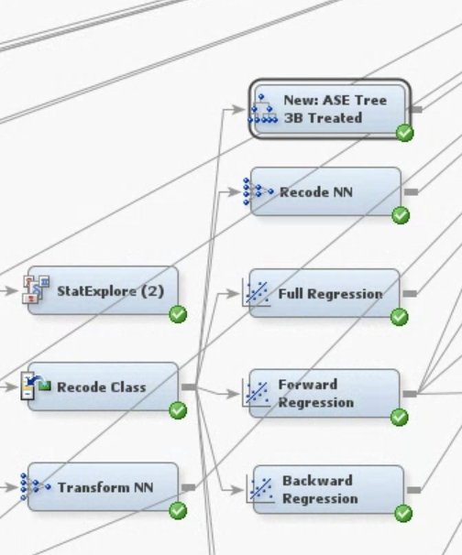

However, this tree performed significantly worse, with an ASE of 0.169793 and a misclassification rate of 0.247325.

## Model Comparison: Trees

Since we have created a few decision trees, we attached a model comparison node to all the trees. This node gives a concise snapshot of all the relevant statistics. In short, ASE with 3 branches is the Best Optimal Tree with 0.169517, followed by ASE 3-branch Tree with 0.169793. The Maximal Tree places 3rd with 0.173235, and the least reliable tree is Misclassification Tree with 0.175272. Screenshot below:

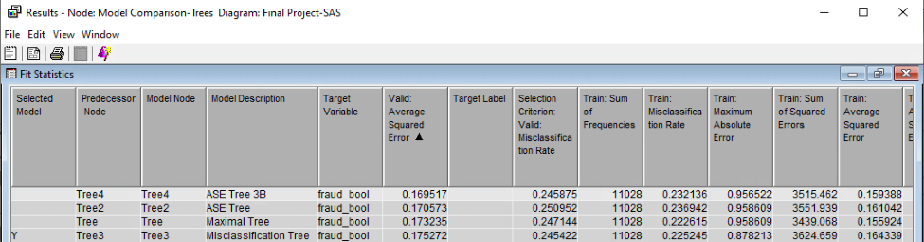

# Data Manipulation

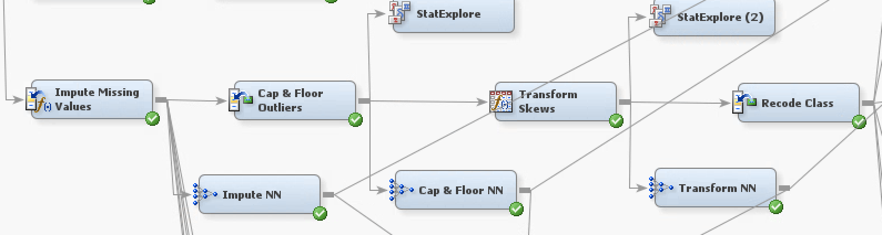

We have followed the following processes to refine our data:

1. Impute Missing Values-After partitioning the data 50:50, we were still left with significant missing values. When it comes to regression, we could have left the missings untreated, but we preferred to work with a treated dataset. As per the screenshot below, we had up to 80% data missing in some cases.

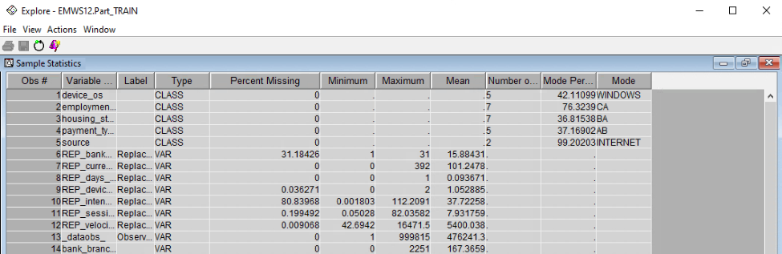

The customizations we used for the impute node are given below:

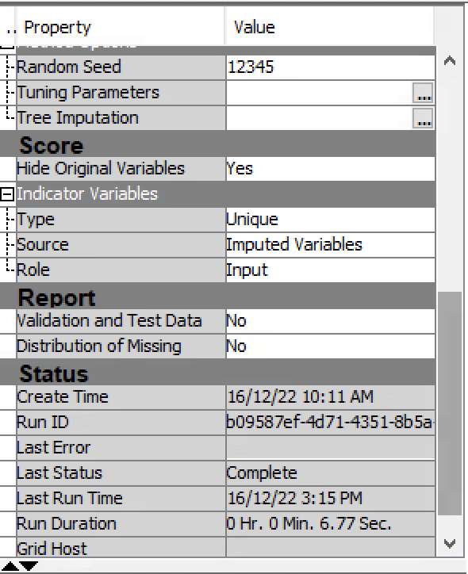

After running the impute node, new variations of inputs were created with the prefix IMP short for impute. From the picture below, M_REP_banks_months_count had 31.184% missing, which is now 0% as per the new imputed version( IMP_REP_bank_months_count). The results are similar for both training and validating data.

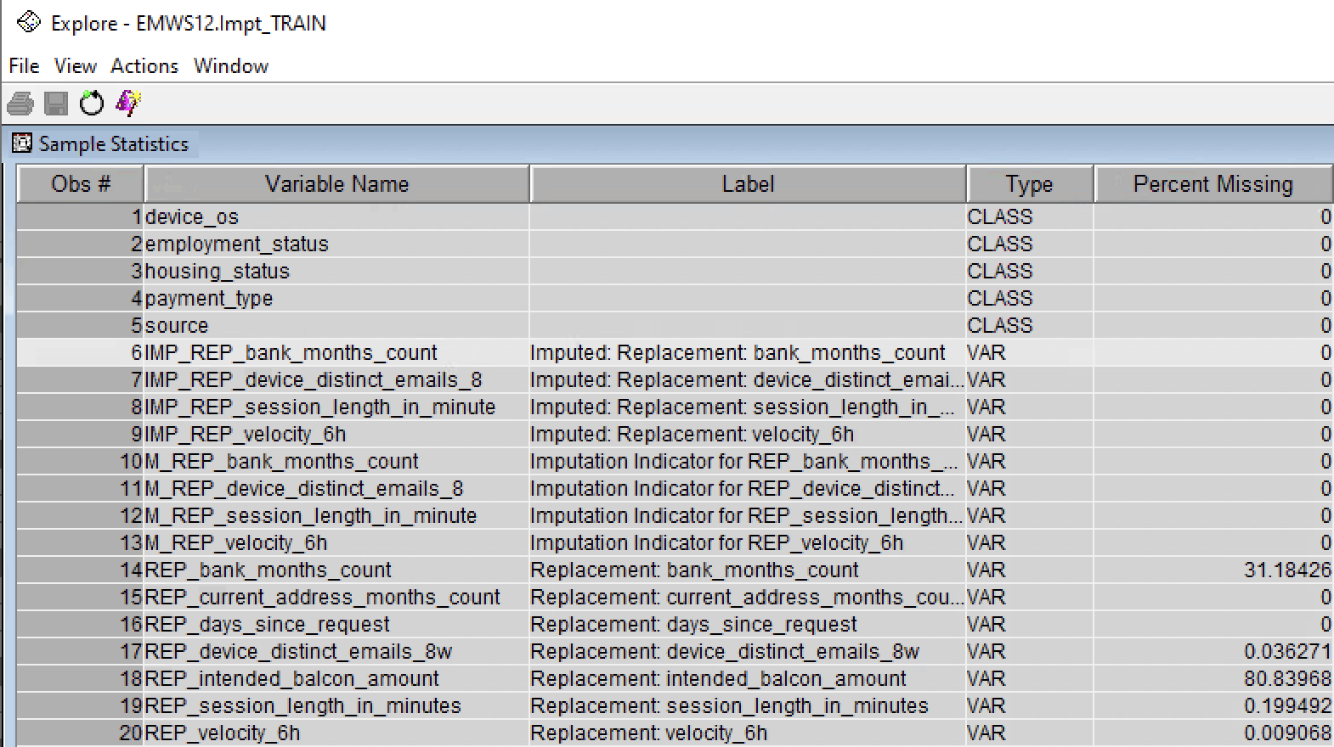

1. Cap and Floor-Having treated missings, we needed to adjust the outliers in the dataset. We added a replacement node to cap and floor the extreme values.

Results referred to below after running Cap & Floor:

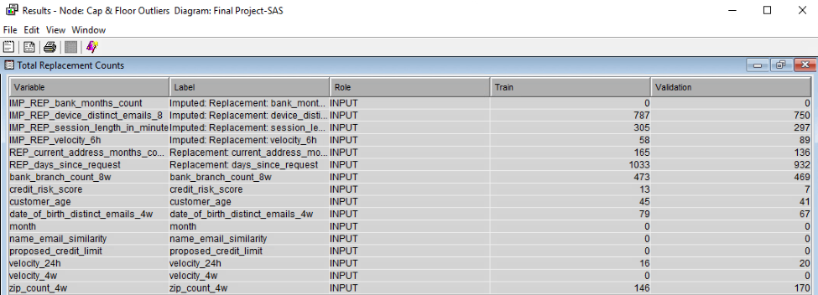

There have been multiple replacements in the overall dataset. For instance, customer age had 45 replacements in train data and 41 in validation data. The previous maximum age was 90 years old (refer to StatExplore in Data Exploration). Now the upper limit is 76.097 (screenshot below):

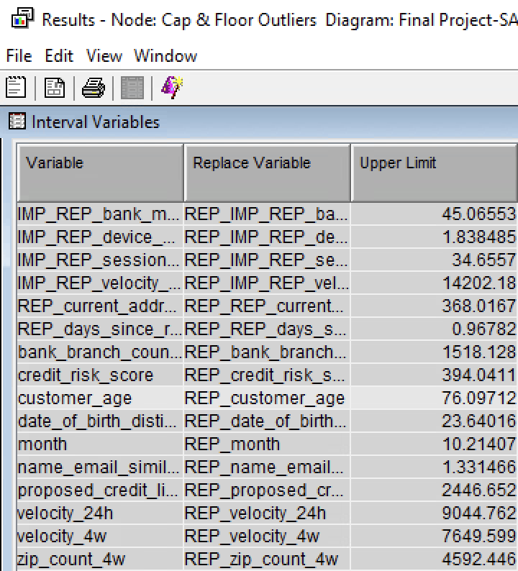

The following screenshot is a consolidated list of all the upper and lower limits for each variable. The range between the limits is quite vast in terms of magnitude. There are chances of skews sustaining.

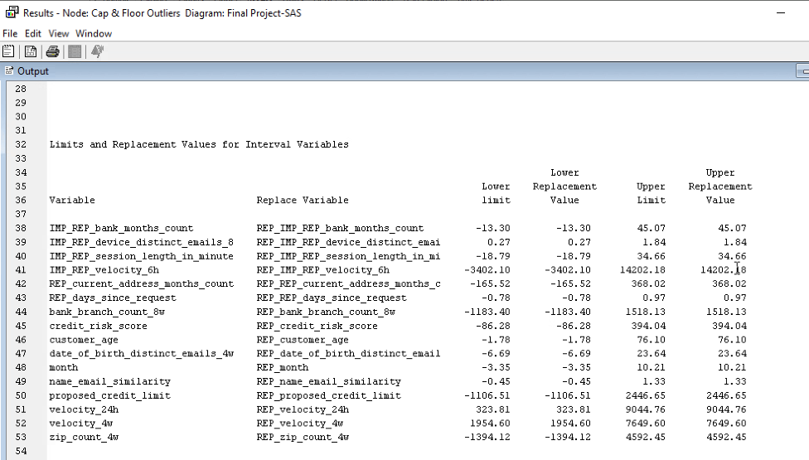

1. Transform Skews-The initial skews for the inputs were as high as 9 whereas it should be between -1 to 1.

The skews below show the before of transformation. Most of the variables are skewed positively. Three of the highly skewed variables are:

* REP_IMP_REP device_distinct_email- 3.9.
* REP_bank_branch_count_8w-3.15
* REP_REP_days_since_request -2.95

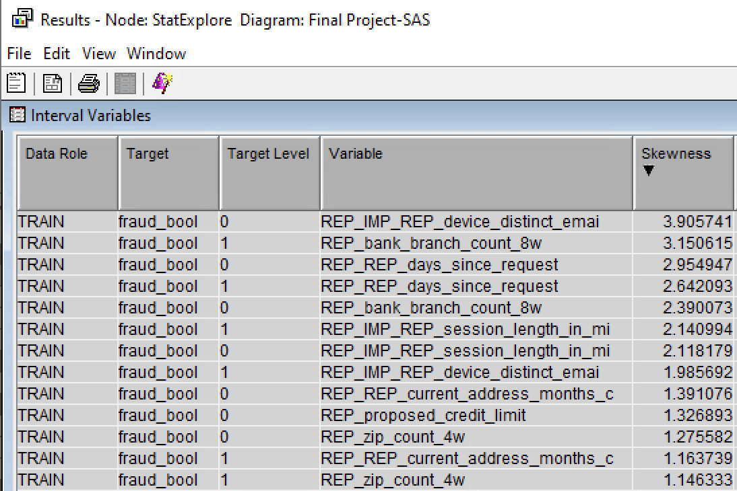

We edited the variables with the highest skews with a log transformation. In the variables edit panel, we opened the interval variables and chose ‘log’ instead of ‘default’ to minimize skew. We changed 6 variables. The variables are given below:

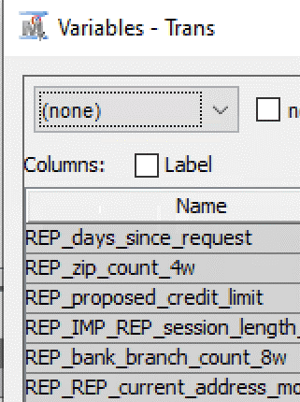

After transforming variables, the skews are as follows:

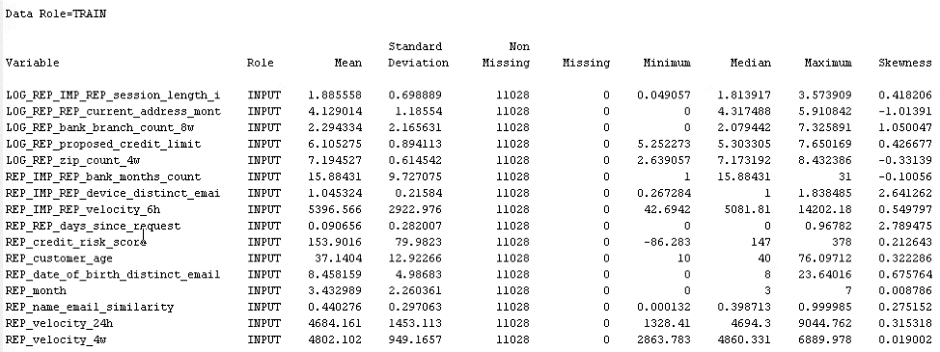

Most of the skews have reduced and come inside the acceptable range of -1 to 1. There are only 2 variables where skews still persist, device_distinct_email and days_since_request. Both are around 2 which is still an improvement over the pre-transform state. After careful consideration, we have decided to leave these 2 variables as is. This decision was solely made to retain the natural state of the data. We could have manipulated the data to reach a desired range between -1 to 1, however, doing so we would have tweaked the data well beyond its original comprehension. Manipulation helps eliminate noise in the data, bring structure, and derive clearer relationships among variable. On the other hand, we are letting go of some of the originality which may or may not be crucial to understand the causal relationship with the dependent variable. In this case, we already had performed multiple modifications and aligned most variables within our desired threshold, any more modification would have caused more harm than benefit.

1. Recode Class Variables-All the transformations done so far mostly impacted interval variables. In the case of class variables, we wanted to recode some class variables. We were given limited options in the dataset. The only options which made sense were:

* Employment status
* Housing status
* Payment type
* Income

The first 3 options on paper seem feasible, however, the data dictionary did not suffice. Very little clarity was provided on the acronyms, hence, we did not have a basis to group the classes.

Income was naturally the only variable we decided to recode. Classes ranged from 0.1 to 0.9. We divided the data into 3 classes and took the mean for each class and denoted the class with the mean value. For example, 0.1, 0.2, and 0.3 all were classed as 0.2. Due to SAS limitations, we could not assign the degree of income in terms of ‘High’, ‘Med’, and ‘Low’, though it would have been ideal.

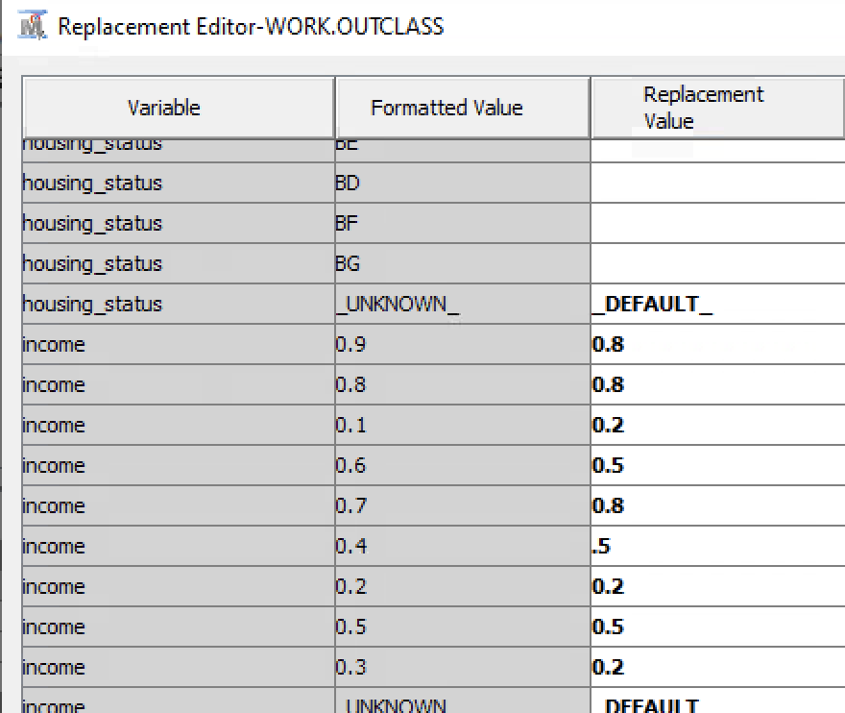

# Regressions

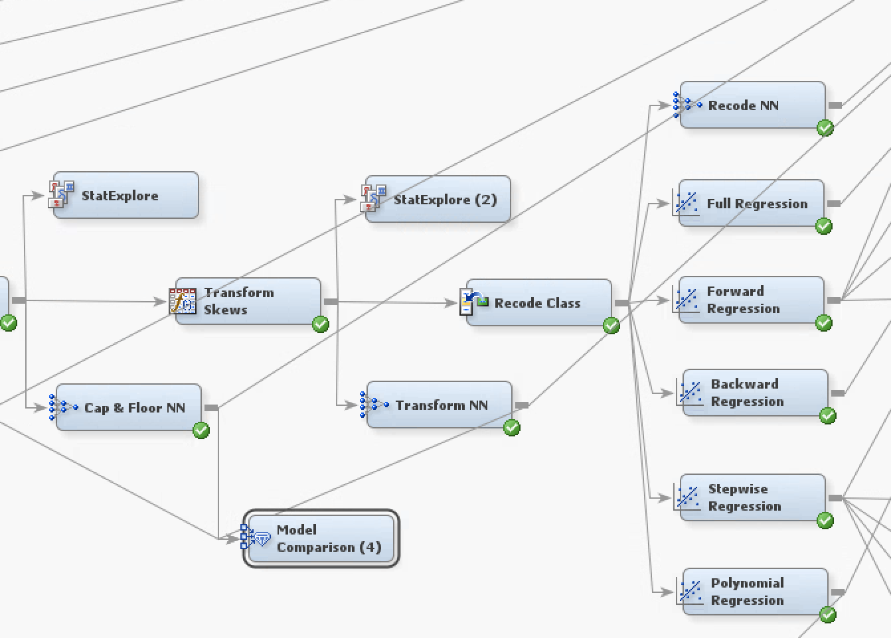

For our model, we have chosen logistic regression for the analysis.

Logistic regression uses previous observations from a data set to predict a binary outcome, such as yes or no. By examining the correlation between one or more already present independent variables, a logistic regression model forecasts a dependent data variable.

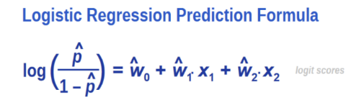

We have used 4 types of regression i.e.,

* Full Regression
* Forward Regression
* Backward Regression
* Stepwise Regression
* Polynomial Regression

## Full Regression

We first conducted a full regression of our model. As per the screenshot it can be depicted that the ASE of full regression is **0.141961**.

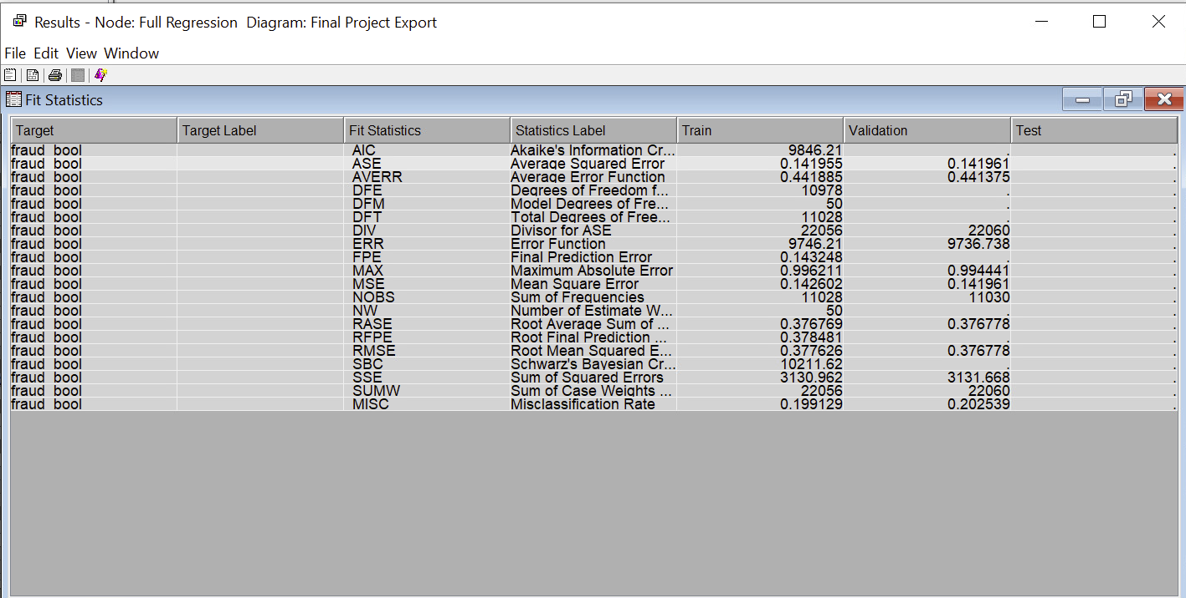

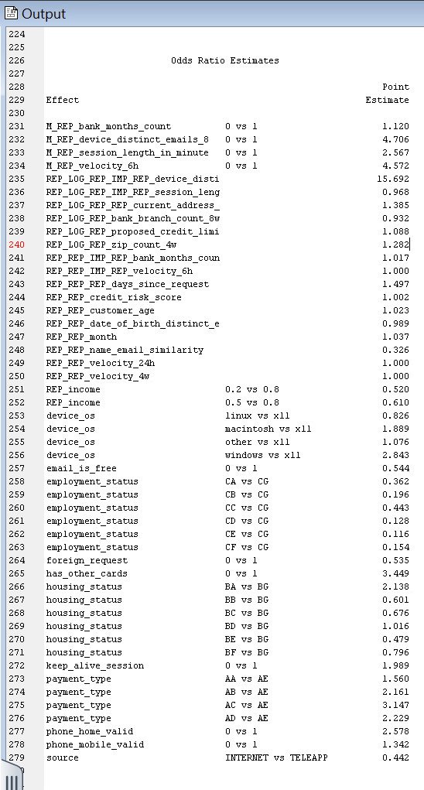

As per the odds ratio, for every one unit increase in the M_REP_bank_months_count variable, the odds of bank application fraud increase by approximately 12.0%. Customers with M_REP_device_distinct_emails_0 have approximately 4.7 times higher odds of being involved in fraud compared to customers without this characteristic. Customers with higher M_REP_velocity_6h have significantly higher odds of being associated with bank fraud. Specifically, for each unit increase in M_REP_velocity_6h, the odds of bank fraud increase by approximately 4.6 times. Customers with REP_LOG_REP_IMP_REP_device_distinct_emails are approximately 15.7 times more likely to be involved in bank fraud compared to customers without this characteristic. Comparing all log transformed variables, REP_LOG_REP_IMP_REP_device_distinct_emails is more related to application fraud. Customers with device_os of x11 are 88% more likely to be involved in fraud as compared to those with macintosh. Customers with housing_status of BG the odds of bank fraud increase by approximately 2.1 times as compared with customers with housing_status of BA.

## Forward Regression

For forward regression, we changed the model selection to forward and the selection criteria are Validation error.

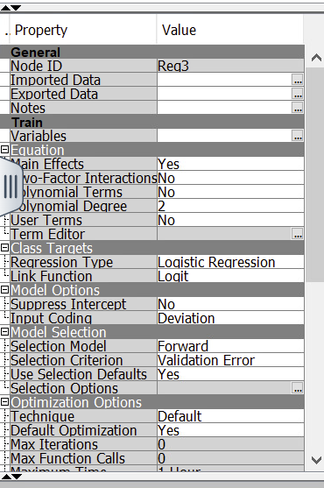

As per the forward regression model, our ASE is **0.141946** which is slightly better than full regression.

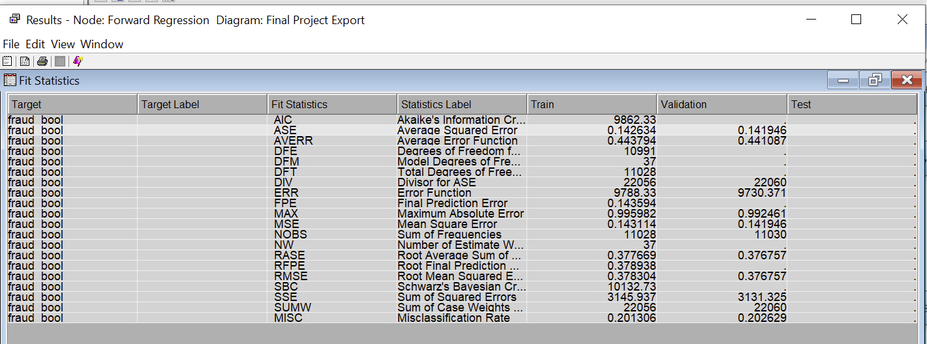

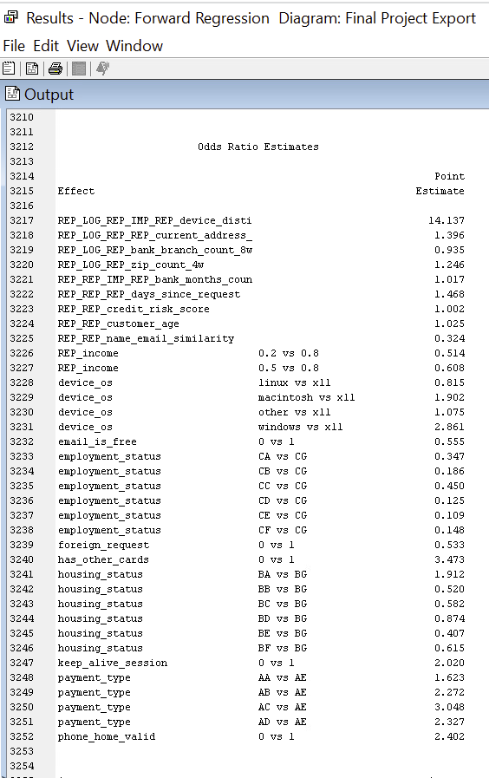

Customers with REP_LOG_REP_IMP_REP_device_disti have approximately 14.1 times higher odds of being involved in bank fraud compared to customers with a lower count of distinct devices. Our missing variable which has been treated after impute, REP_REP_IMP_REP_bank_months_coun for each unit increase in it, the odds of bank fraud increases by approximately 1.6%. Customers with REP_LOG_REP_REP_current_address have approximately 1.4 times higher odds of being associated with bank application fraud compared to customers without a current address. Customers with device_os of x11 are 90% more likely to be involved in fraud as compared to those with macintosh. Customers with housing_status of BG the odds of bank fraud increase by approximately 90% more likely to be involved in fraud as compared with customers with housing_status of BA. payment_type AE is 3 times more related to fraud as compared with AC. Customers with foreign_request the odds of bank fraud decreased by 46.7% as compared to those without foreign_request.

## Backward Regression

For backward regression we changed the model selection to backward and the selection criteria is Validation error.

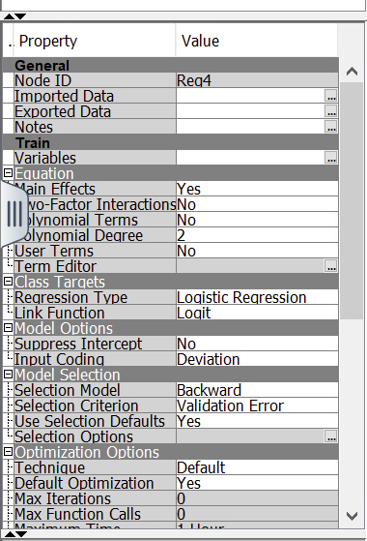

As per backward regression model, our ASE is **0.141983** which is worse than full and forward regression.

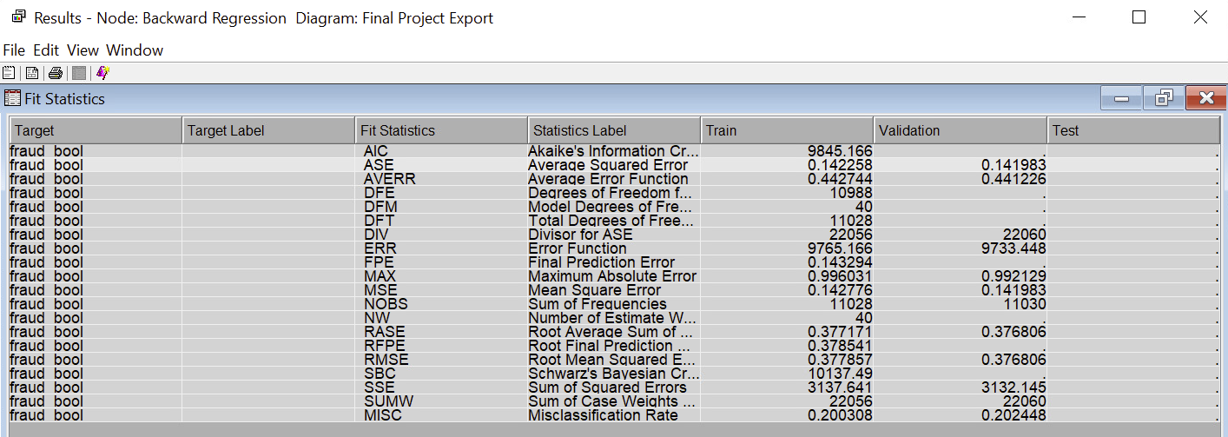

Customers with REP_LOG_REP_IMP_REP_device_disti have approximately 14.2 times higher odds of being involved in bank fraud compared to customers with a lower count of distinct devices. Our missing variable which has been treated after impute, REP_REP_IMP_REP_bank_months_coun for each unit increase in it, the odds of bank fraud increases by approximately 1.7%. Customers with REP_LOG_REP_REP_current_address have approximately 1.4 times higher odds of being associated with bank application fraud compared to customers without a current address. Customers with device_os of x11 are 86% more likely to be involved in fraud as compared to those with macintosh. Customers with housing_status of BG the odds of being involved in bank fraud is 2 times more as compared with customers with housing_status of BA. payment_type AE is 2.9 times more related to fraud as compared with AC. Customers with foreign_request the odds of bank fraud decreased by 46.7% as compared to those without foreign_request. If a customer has_other_cards then they are 3.47 times more likely to be involved in application fraud as compared with those who has not.

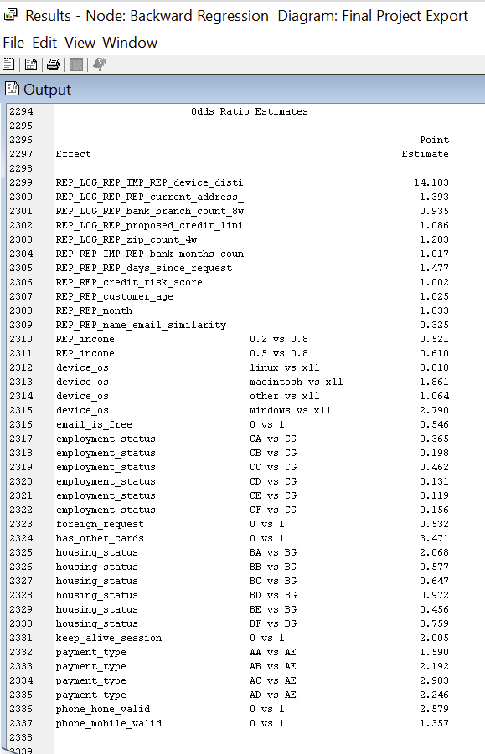

## Stepwise regression

For stepwise regression, we changed the model selection to stepwise and the selection criteria is Validation error.

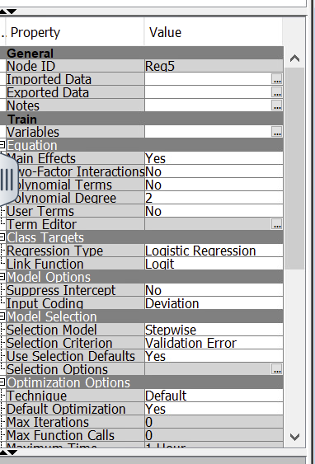

As per stepwise regression model our ASE is **0.141946** which is the same as forward regression.

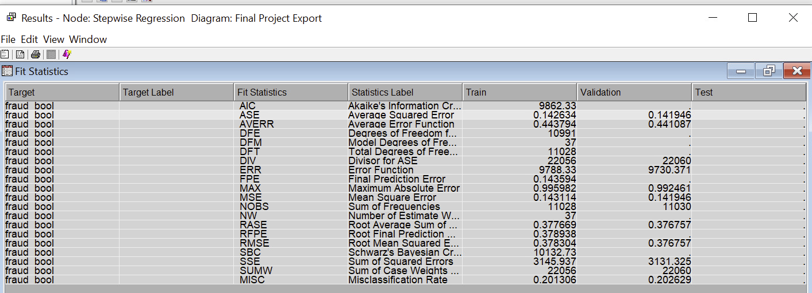

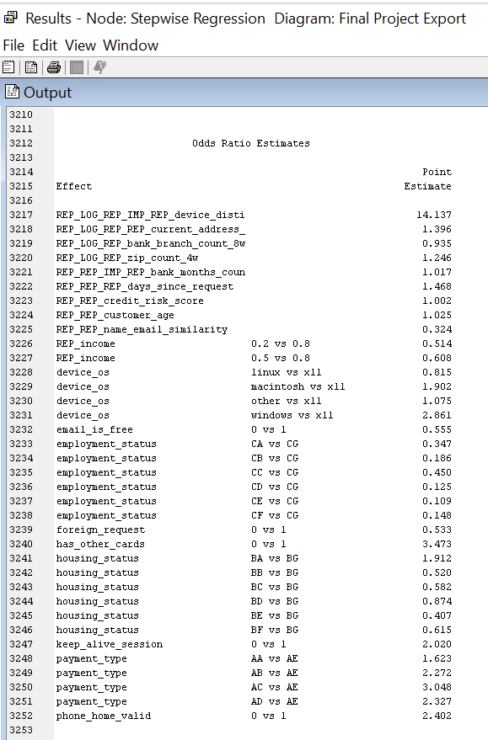

Customers with REP_LOG_REP_IMP_REP_device_disti have approximately 14.1 times higher odds of being involved in bank fraud compared to customers with a lower count of distinct devices. Our missing variable which has been treated after impute, REP_REP_IMP_REP_bank_months_coun for each unit increase in it, the odds of bank fraud increases by approximately 1.6%. Customers with REP_LOG_REP_REP_current_address have approximately 1.4 times higher odds of being associated with bank application fraud compared to customers without a current address. For every one unit increase in the bank branch count, the odds of bank fraud decrease by approximately 6.5%. . Customers with device_os of x11 are 90% more likely to be involved in fraud as compared to those with macintosh. Customers with housing_status of BG the odds of bank fraud increase by approximately 90% more likely to be involved in fraud as compared with customers with housing_status of BA. payment_type AE is 3 times more related to fraud as compared with AC. Customers with foreign_request the odds of bank fraud decreased by 46.7% as compared to those without foreign_request. Customers with employment_status of CG the odds of bank fraud decrease by approximately 55% as compared with customers with employment_status of CC.

## Polynomial regression

For stepwise regression we didn’t change any model selection and the selection criteria but instead we made changes in the equation tab.

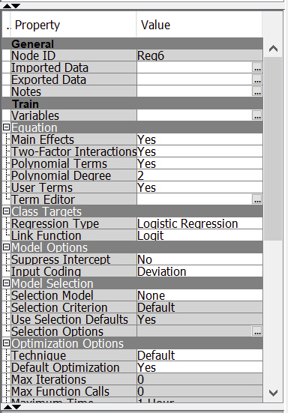

As per polynomial regression model, our ASE is **0.14156** which is best amongst all the regression models.

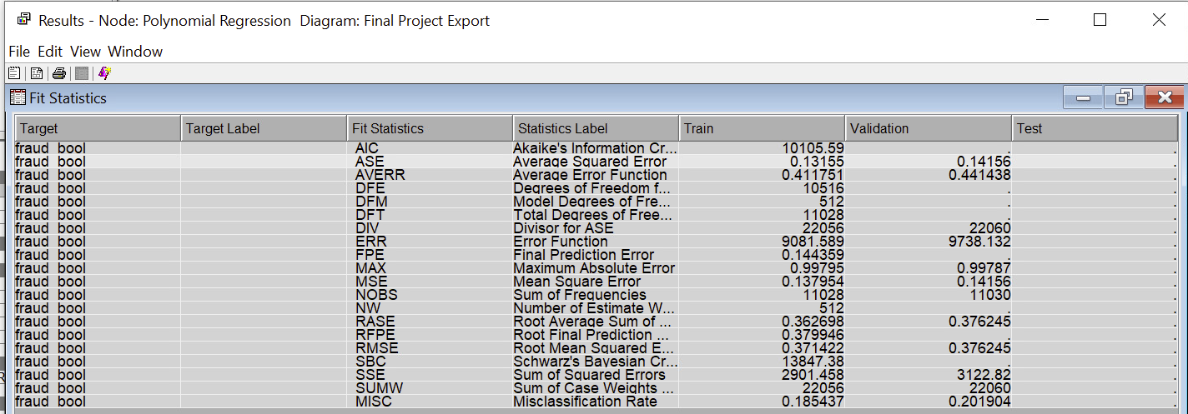

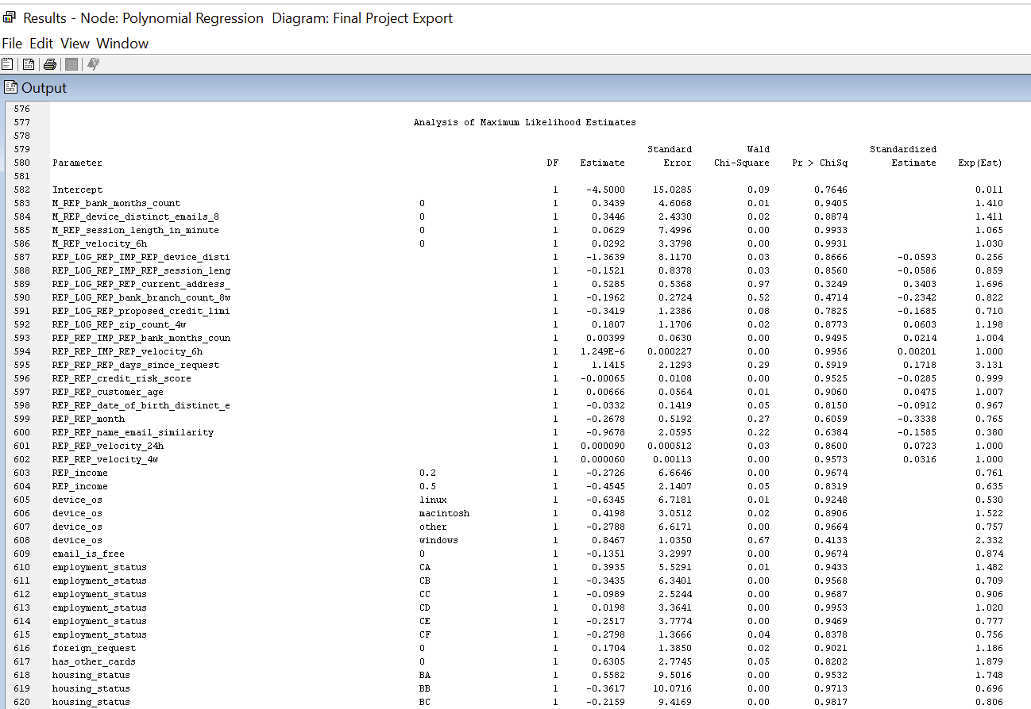

Unlike other regressions, polynomial regression is a bit harder to comprehend. As for the results, the odd estimates may not be the best parameter to associate correlations among the dependent and independent variables. We will be prioritizing ASE in this case.

# Neural Networks

A neural network is a collection of linked input-output variables, where each link has a certain weight that affects the result. The input variables for neural networks are linear combinations of nonlinear functions. This methodology is strong as well as very generic for both regression and classification, and it has been proven to be the most effective machine learning technique for a variety of issues.

We attached neural nodes to 5 sections:

* Decision Trees NN
* Forward Regression NN
* Polynomial Regression NN
* Data Manipulation NN
* Additional NN

## Decision Trees Neural Networks

We attached Neural Nodes to our optimal trees to experiment if the error rates get better or not. We kept the number of iterations at 100, and then turned off any preliminary training. Furthermore, we kept the number of hidden units at the default setting which is three.

Screenshot of our NNs attached to optimal trees is given below:

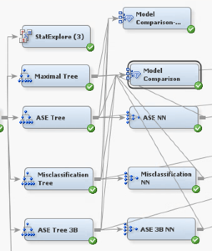

### ASE Neural Network

The below screenshot shows the results we derived from the ASE neural network node. As per the iteration plot, 27 iterations is the best cut-off point as per average squared error metric.

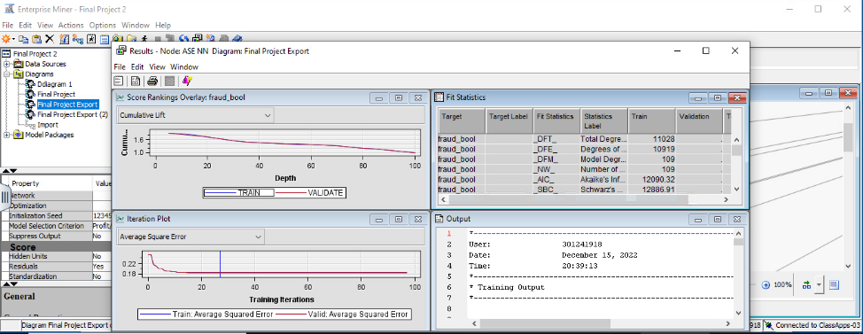

The average square error for ASE Neural network is 0.184877 which is worse than ASE tree with 0.170573 error rate. Hence, this Neural node did not add to ASE tree’s efficiency.

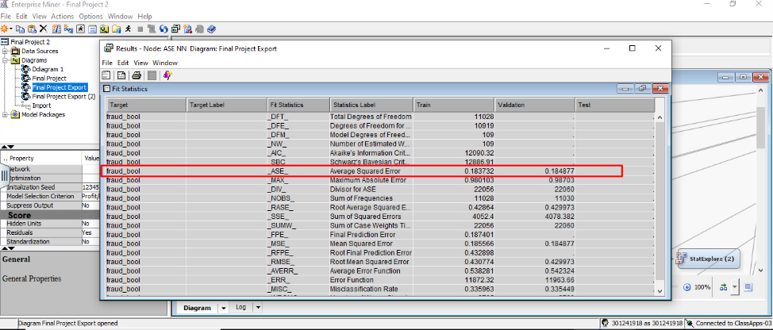

### Misclassification Neural Network

The below screenshot shows the results we derived from the Misclassification neural network node. Unlike, ASE NN , we achieved an iteration cut-off at 18 as per average squared error metric.

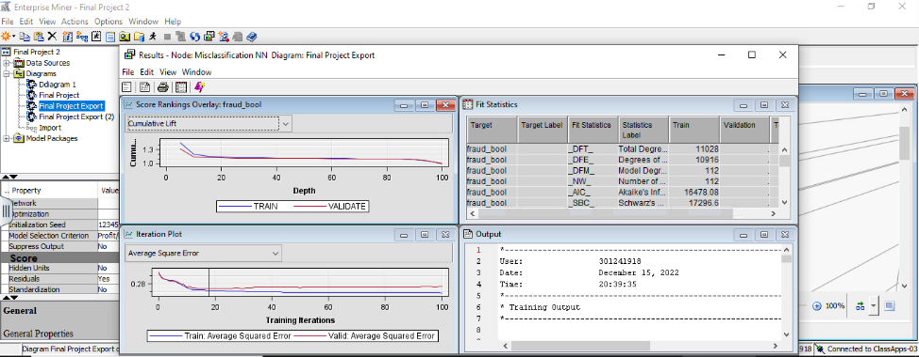

The average square error for Misclassification Neural network is 0.274552 which is highest among all three networks which is much worse than Misclassification Tree at 0.175272 error rate.

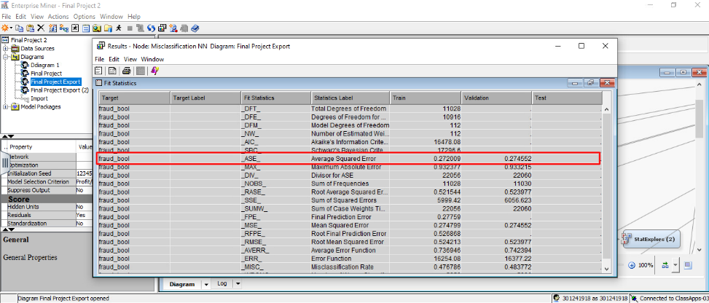

### ASE 3B Neural Network

The number of suggested iterations for this model is an astonishing 96. This is the highest so far for NNs.

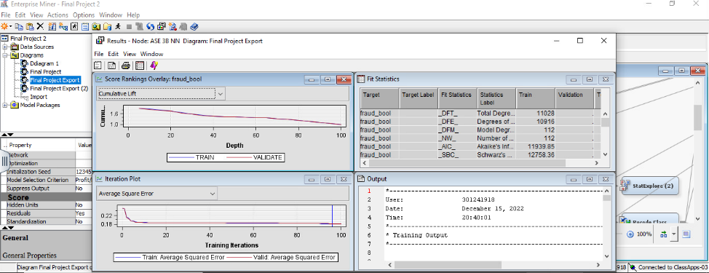

However, the average square error for ASE 3B Neural network is 0.182003 which is lowest among all three nodes. In comparison to ASE 3B Tree, it is much higher, approximately by 0.01.

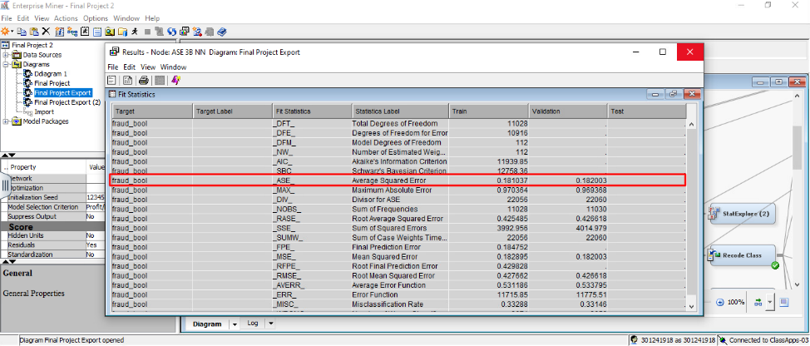

### Summary: Decision Tree NN

|  |  |  |  |
| --- | --- | --- | --- |
| Model | ASE NN | Misclassification NN | ASE 3Branch NN |
| Average Squared Error | 0.184877 | 0.274552 | 0.182003 |
| Misclassification Rate | 0.335449 | 0.483772 | 0.33146 |

## Forward Regression Neural Networks

Here we connect the neural network with the forward regression with various hidden units and iterations. This has been done as one of the last steps in our project. We attached NNs with multiple hidden units to find increasing or decresing efficiency. We started with the default setting of 3 and went upwards. We experimented till the point efficiency started faltering.

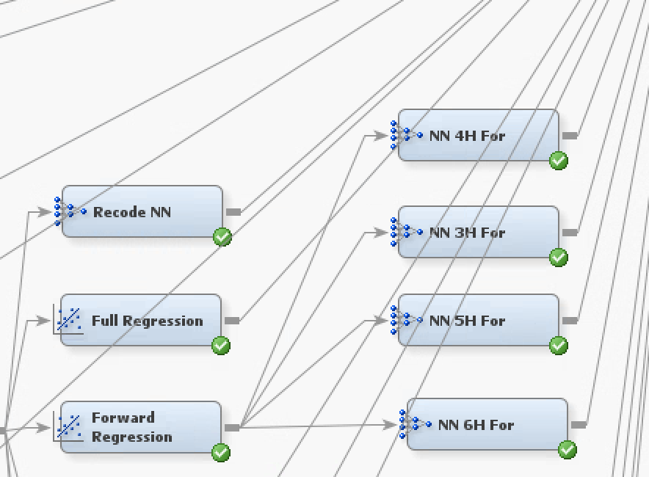

### 3 Hidden Unit Neural Network (100 iterations)

The average square error of a neural network with 3 hidden unit and 100 iterations is 0.139412 with cut-off iterations at 84. Compared to Forward Regression, the error rate has improved from 0.141936

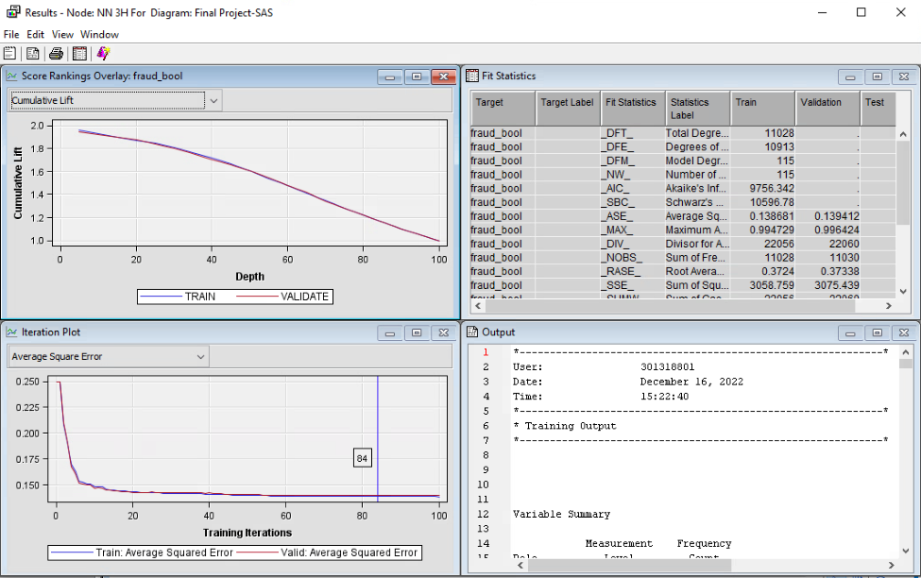

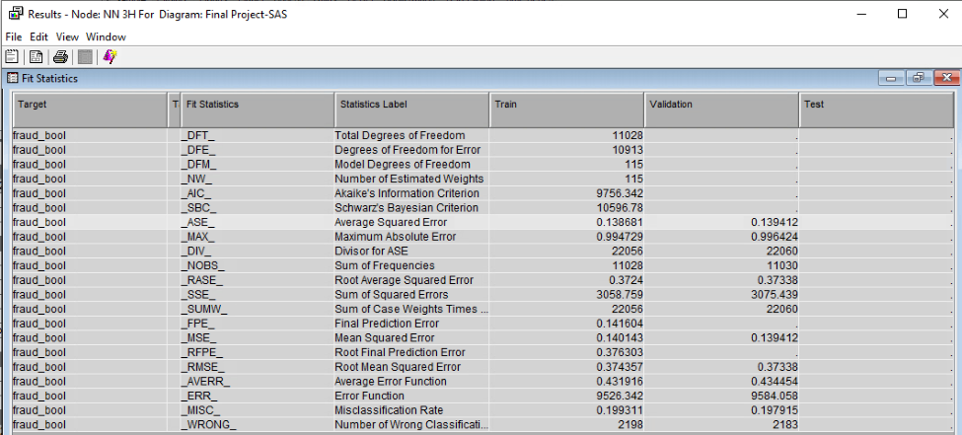

### 4 Hidden Unit Neural Network (100 iterations)

With the hypothesis of improving reliability we kept on increasing hidden units, we approached 4 hidden units. The average square error of a neural network with 4 hidden unit and 100 iterations is 0.139902 which is slightly lower than 3 hidden unit neural network..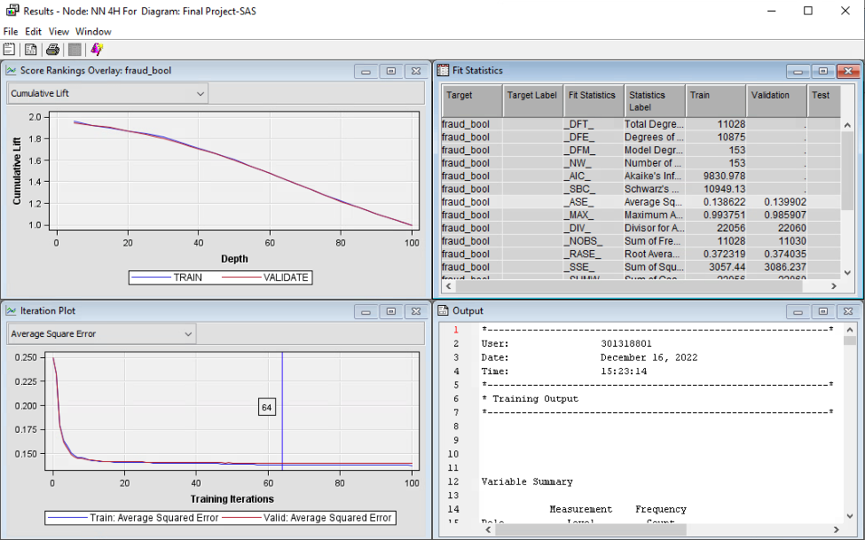

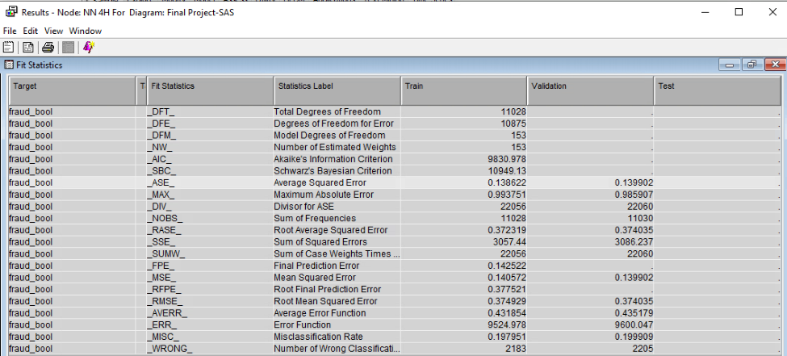

### 5 Hidden Unit Neural Network (100 iterations)

Following the trend of increasing error rates, we went ahead with 5 hidden units. The average square error of a neural network with 5 hidden unit and 100 iterations is 0.139861 which is lowest so far. The sequence of improving rates keeps going on.

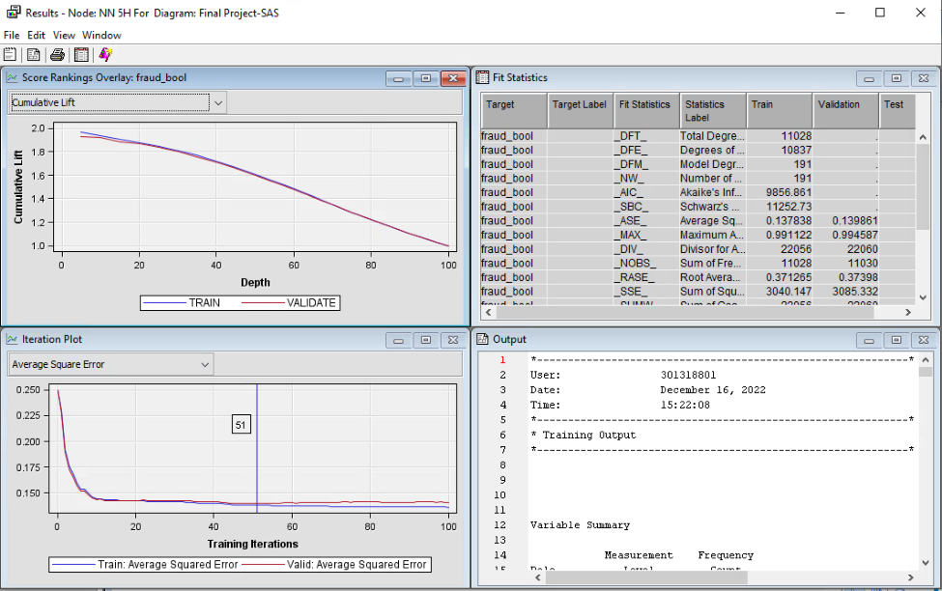

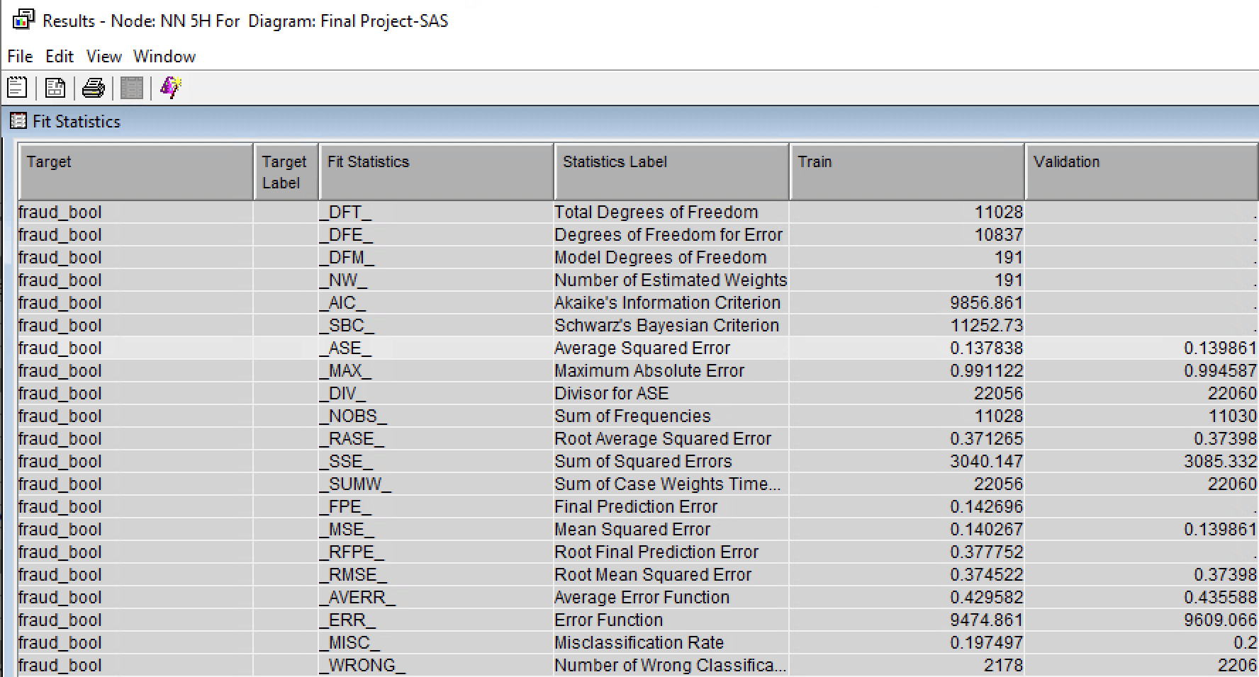

### 

### 6 Hidden Unit Neural Network (100 iterations)

The average square error of a neural network with 6 hidden unit and 100 iterations is 0.140261 which is increasing from the prior hidden unit models. Hence, we stopped here in terms of experimenting with hidden units.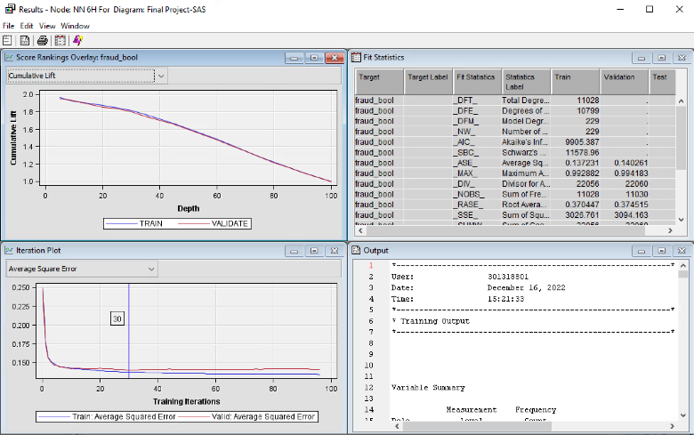

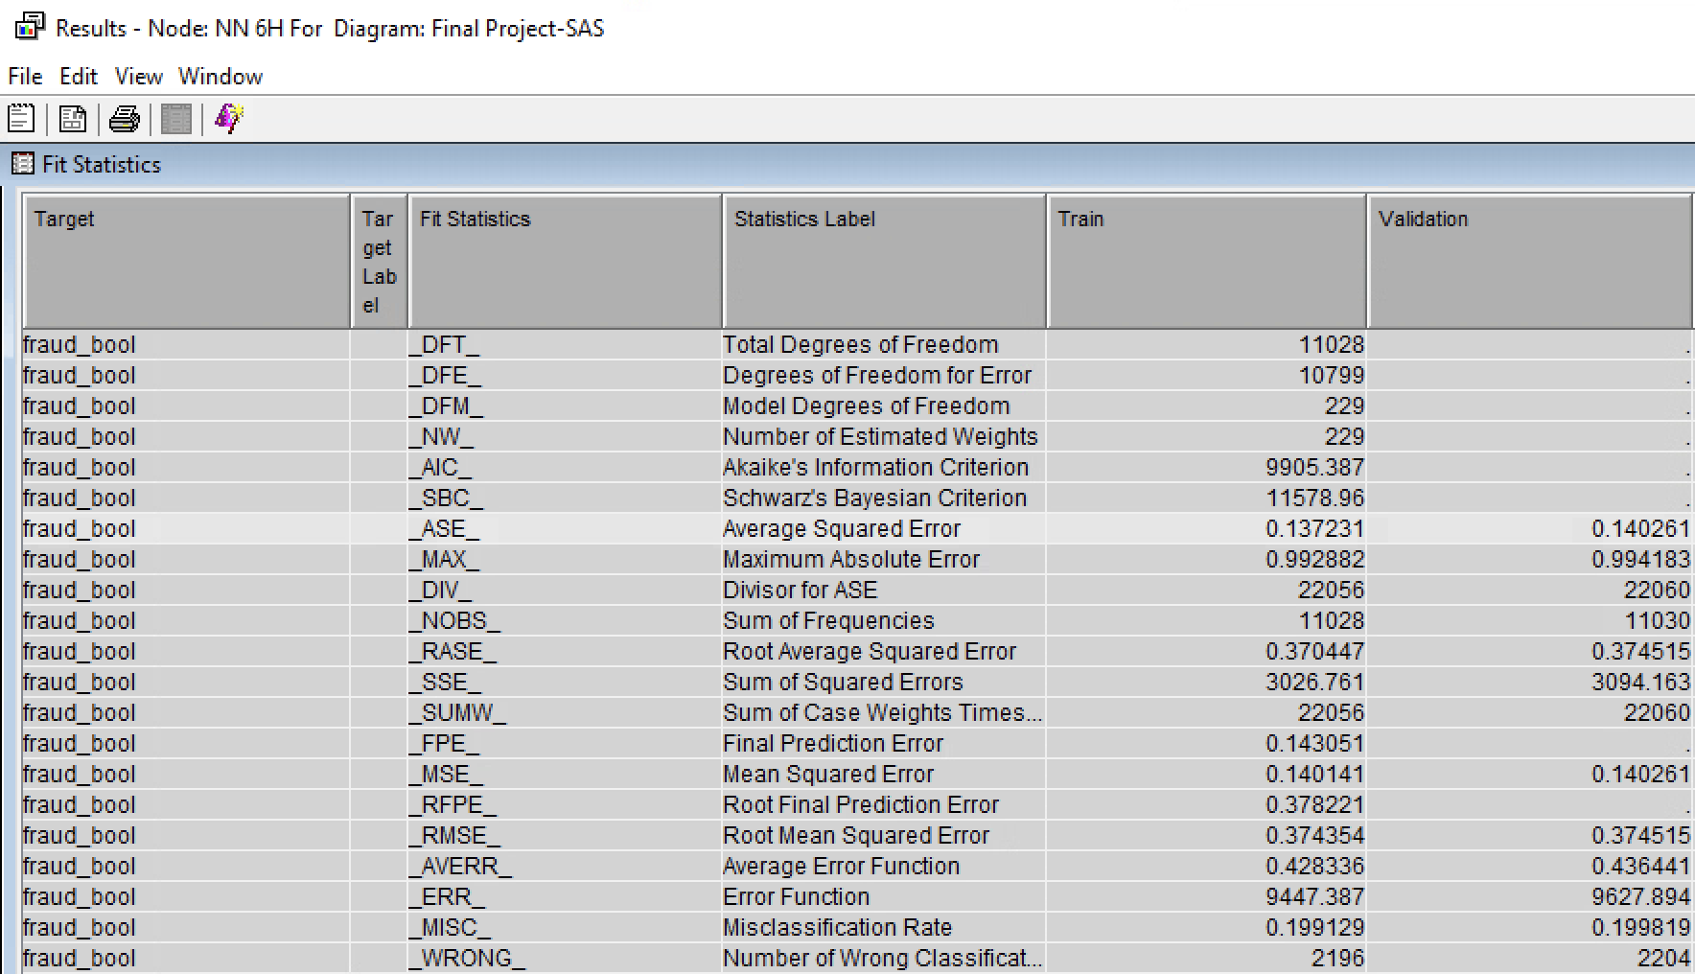

## Polynomial Regression Neural Networks

We did a polynomial regression to cater to the skews which were persistent in our project despite all the changes made through the replacement and transform nodes. Last step taken was changing 6 variables to their log format instead of default. After which all changes were made to class variables.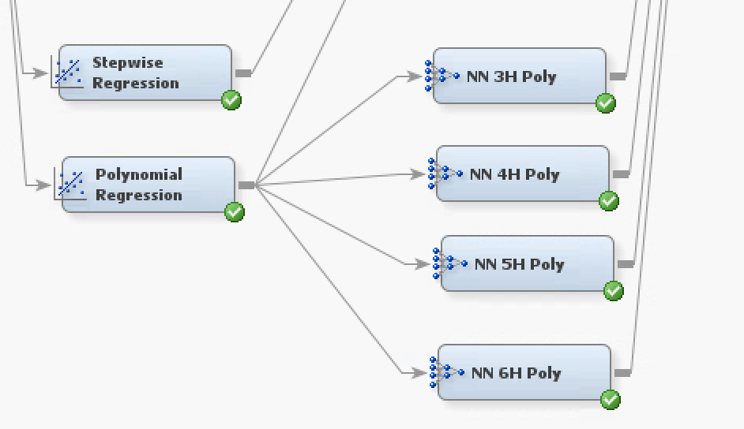

In the case of experimentation with hidden units, we used the same rationale as before. Exercise testing as long as efficiency is being achieved. In short, we used upto 6 hidden units and stopped there due to increasing error rates. Screenshots are shared below for each specification.

### 3 Hidden Unit Neural Network (100 iterations)

The ASE rate for default 3 hidden units was 0.139752. The number of iterations suggested were 36. This error rate is lower than the polynomial regression rate of 0.141826.

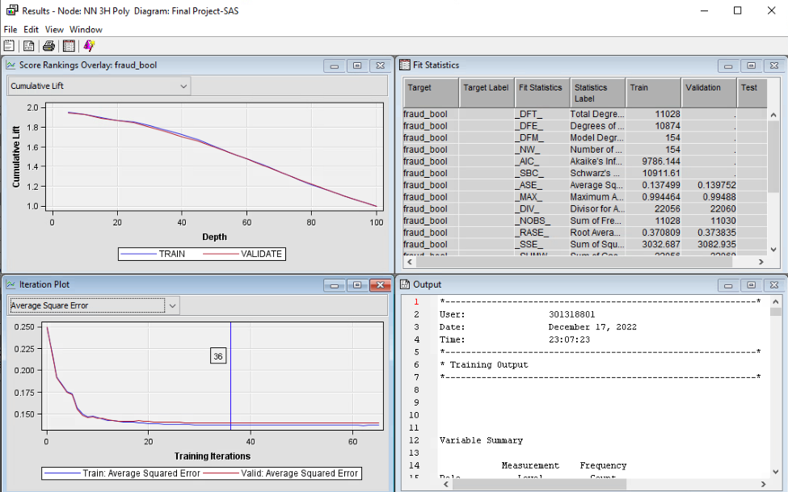

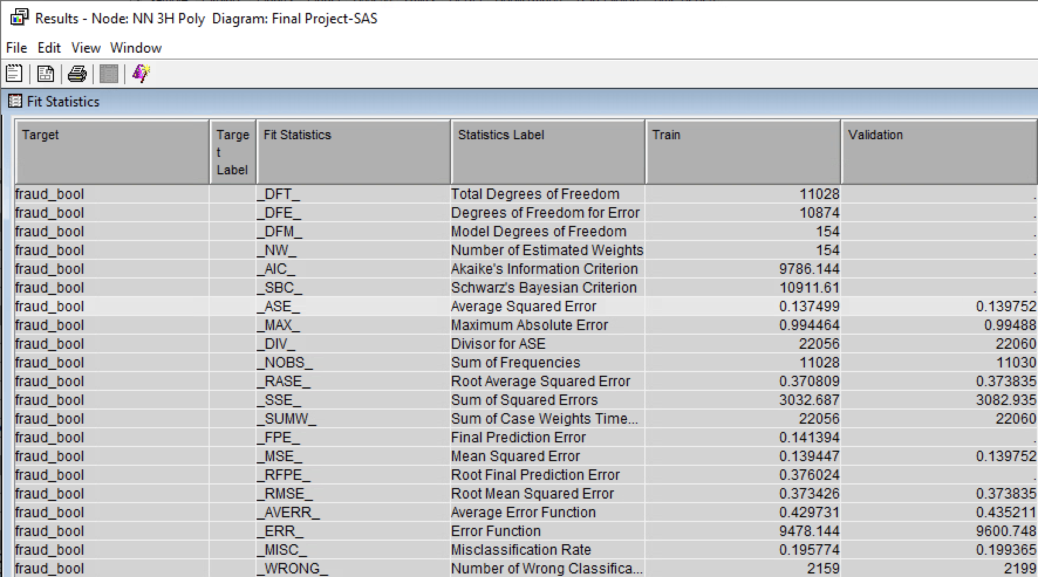

### 4 Hidden Unit Neural Network (100 iterations)

The average square error of a neural network with 4 hidden unit and 100 iterations is 0.140691.

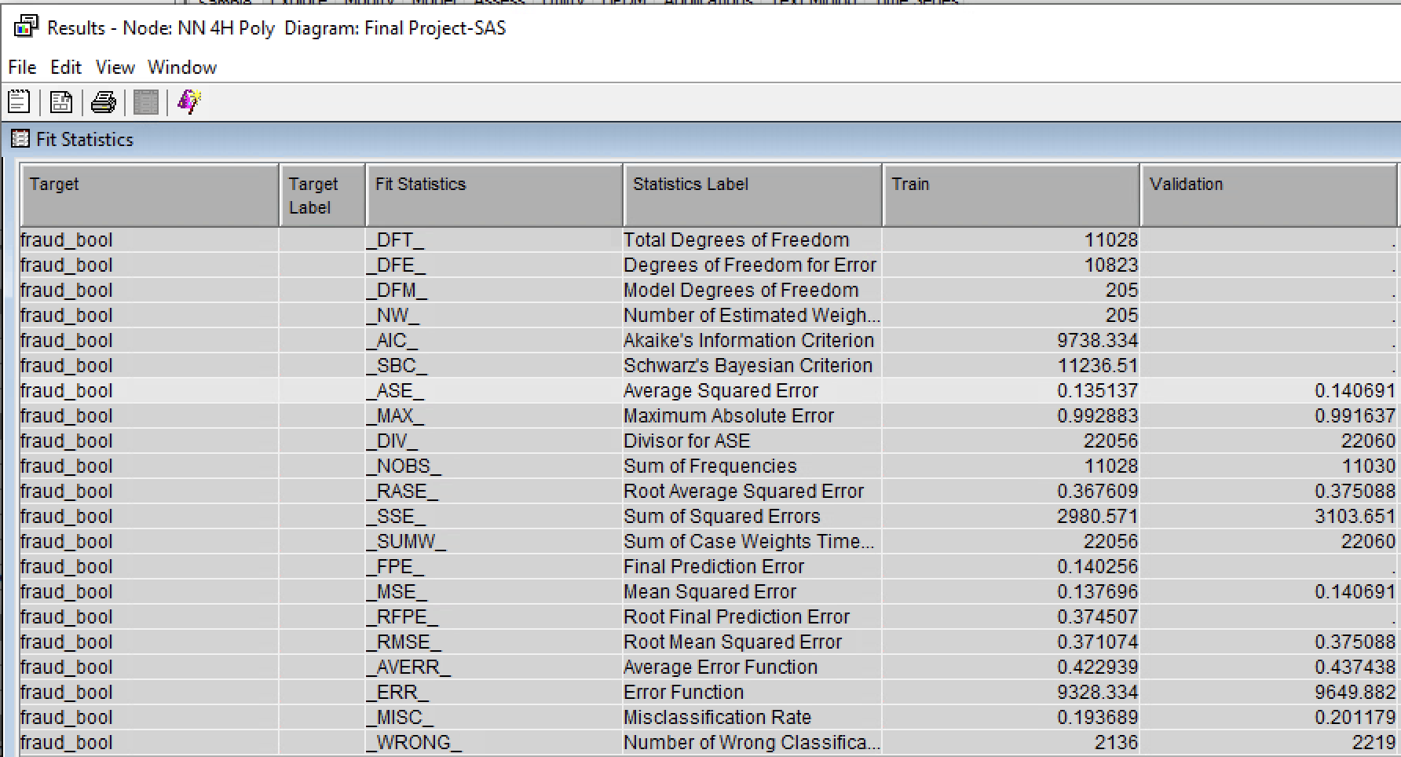

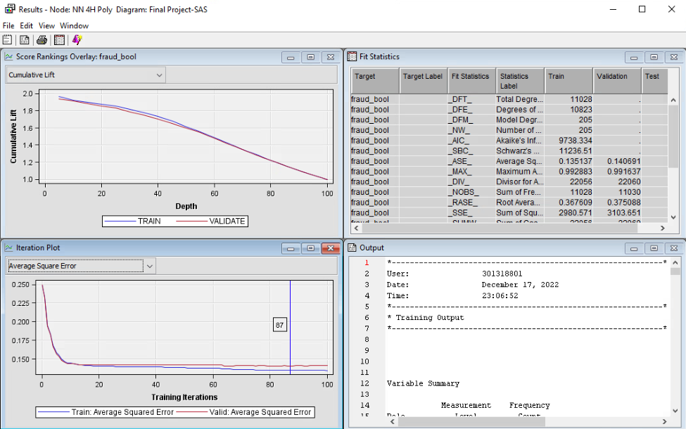

### 5 Hidden Unit Neural Network (100 iterations)

The average square error of a neural network with 5 hidden unit and 100 iterations is 0.139567

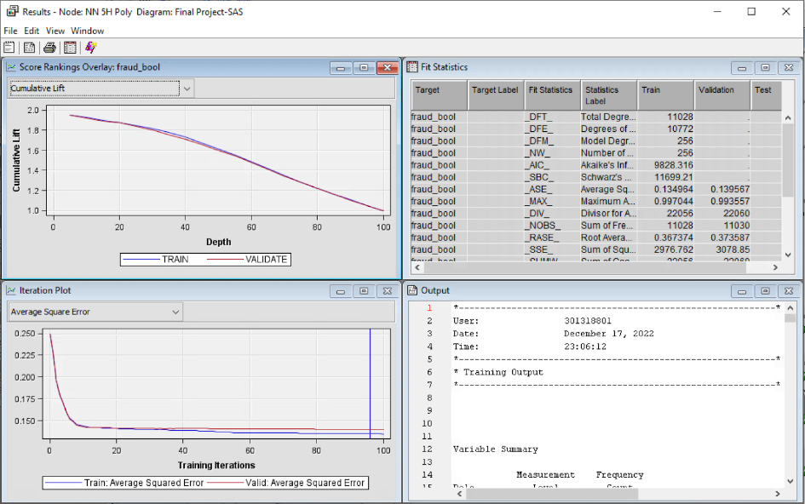

### 6 Hidden Unit Neural Network (100 iterations)

The average square error of a neural network with 6 hidden unit and 100 iterations is 0.140382

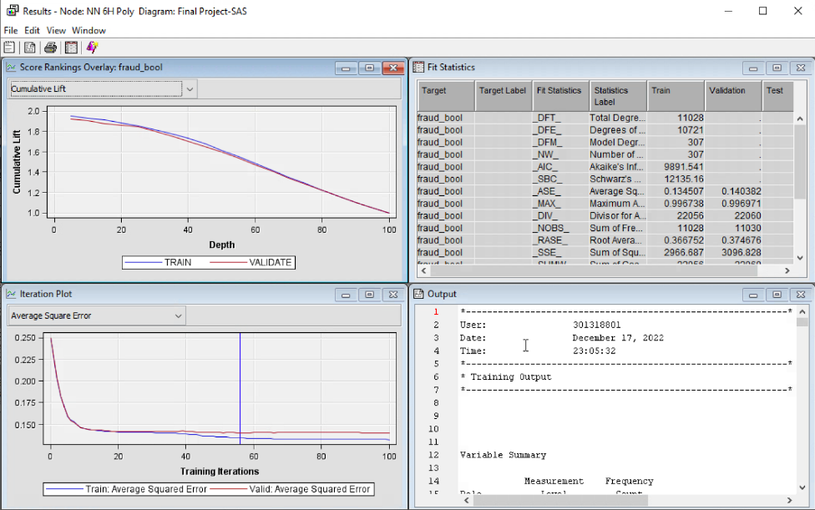

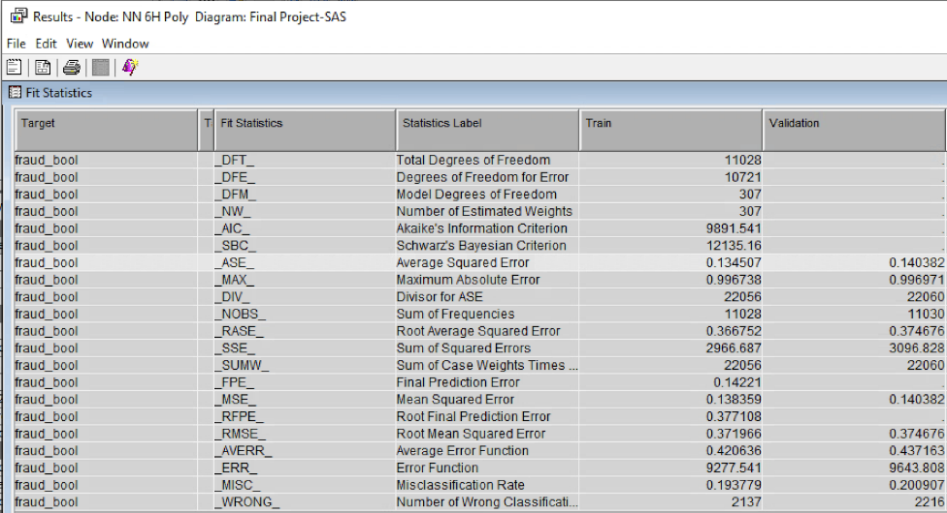

## Data Modification Neural Network

### Impute Neural Network

After imputing missing values in our dataset, we attach a Neural Network node to see if imputing the missing values increases the accuracy of our models.

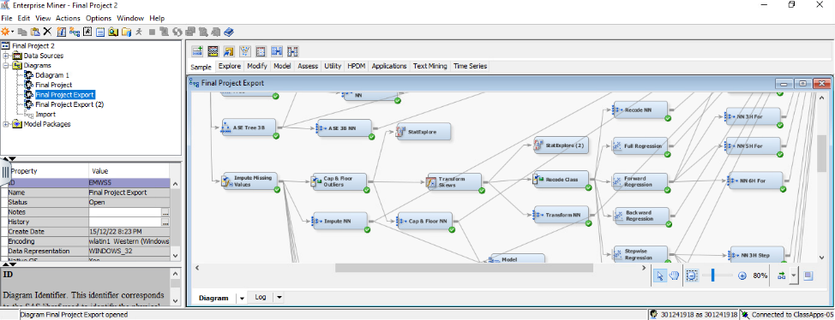

The validation average square error of the impute NN node is 0.138197 and the number of iterations suggested from this model is 82. The ASE we derived from this node is by far one of the best models so far. The closest model that achieved an error rate close to this was the ASE 3 branch model with an ASE of 0.169517. So the accuracy is significantly better.

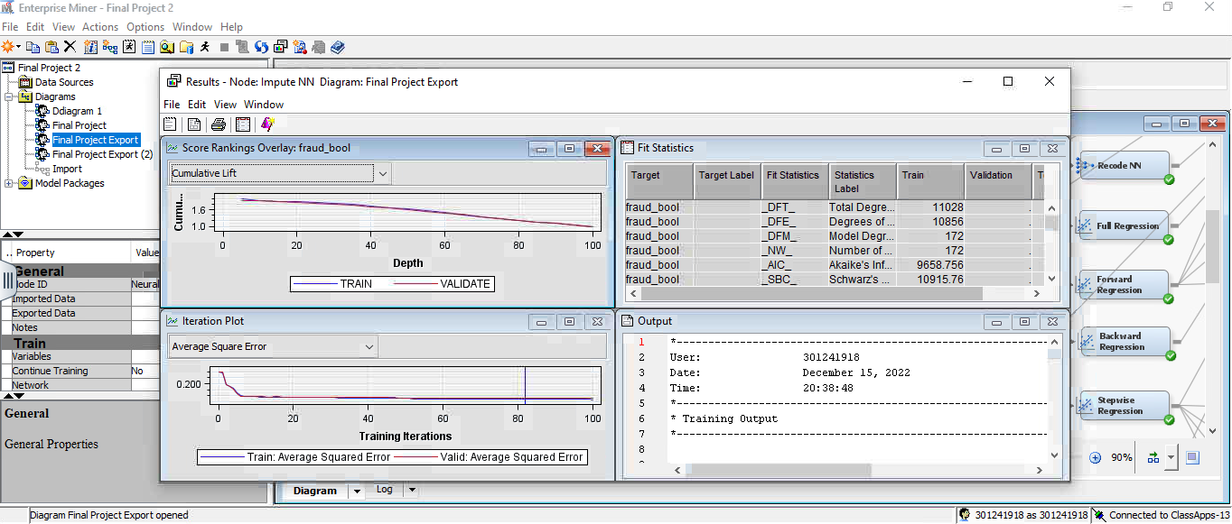

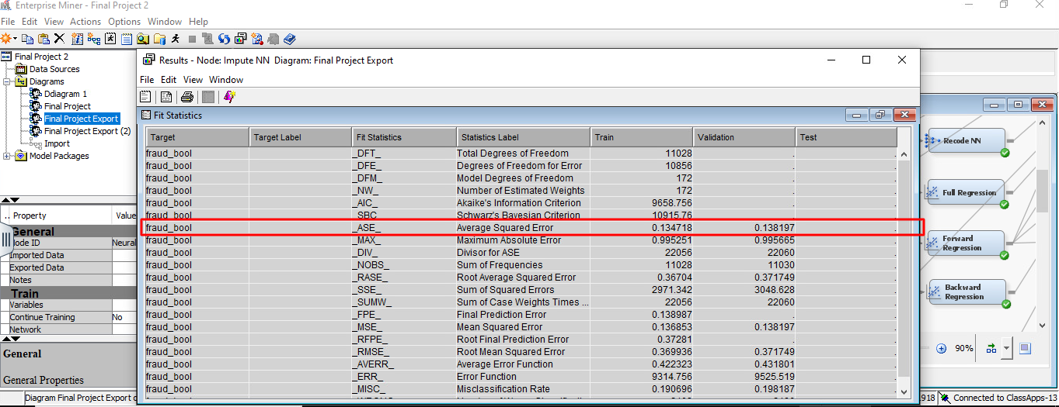

### Cap and Floor Neural Network

After imputing all the missing variables, we added a replacement node to adjust the outliers of the dataset. Cap and Floor suggest the range of values that will be capped or floored by this node. Having run this node, we connected the neural network and below is the screenshot of the results panel.

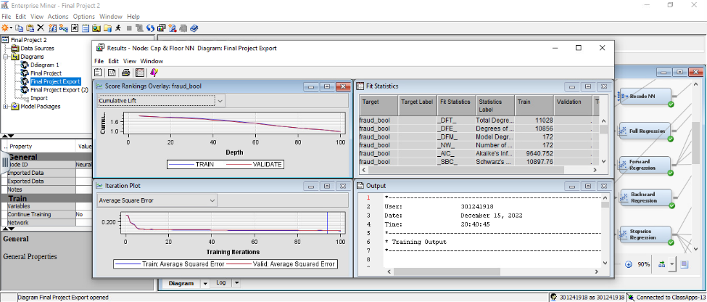

The average square error of the Cap & Floor NN node is 0.137973 and number of iterations is 94. This model has beat the previous Impute NN node by a few decimals only.

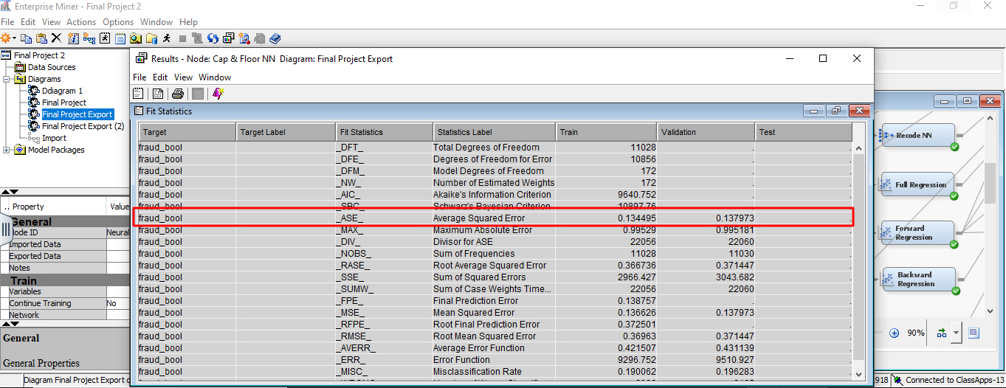

### Transform Neural Network

After applying log transformation to the skews in our dataset, we connect the neural network with the Transform Skews node and below is the screenshot.

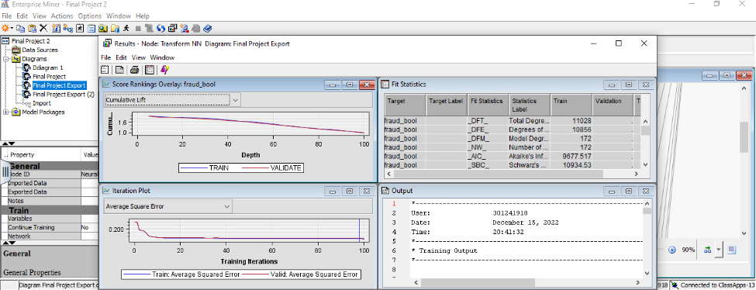

The average square error of the Transform NN node is 0.140211. This however has lower accuracy than the Cap and Floor NN and Impute NN.

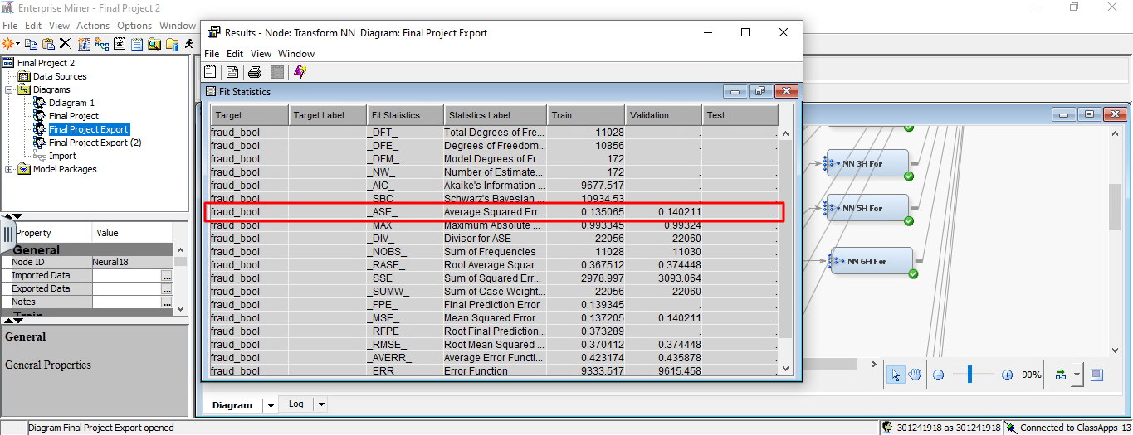

### Recode Class Neural Network

We connect the neural network with the Record Class node as the step of last data manipulation. Screenshot referred below:

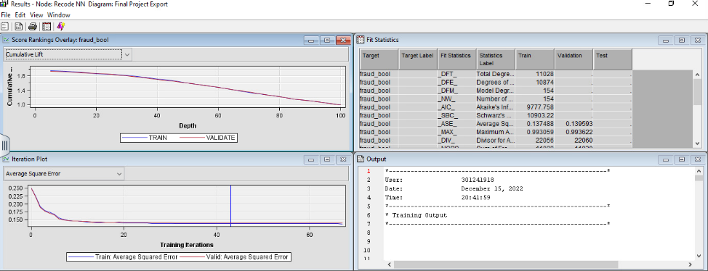

The average square error of the Recode NN node is 0.139593. As it seems, from the data manipulation section Cap and Floor NN and Impute NN are the best models so far.

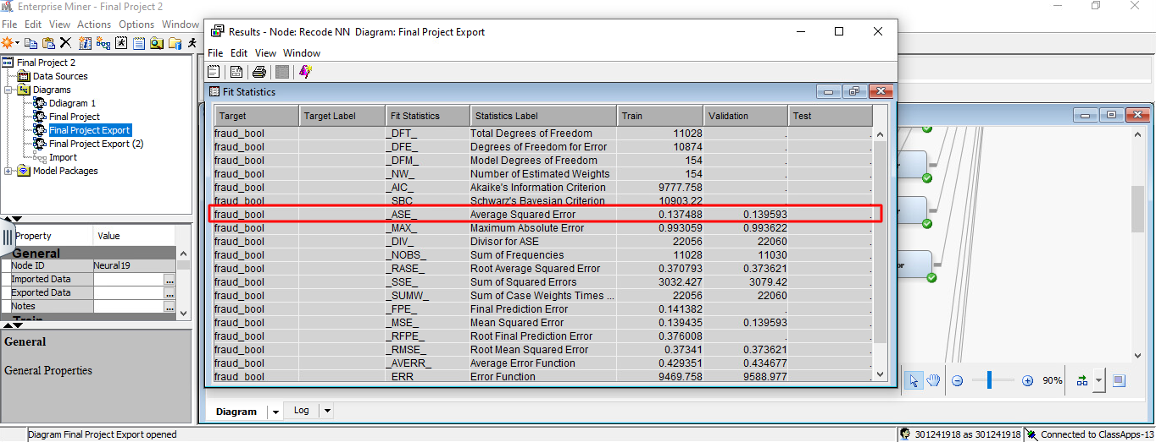

## Other Neural Networks

Besides these neural networks, we also worked on a few more NNs which were extrapolated before any data modification in the interval and class variables. Snapshot below:

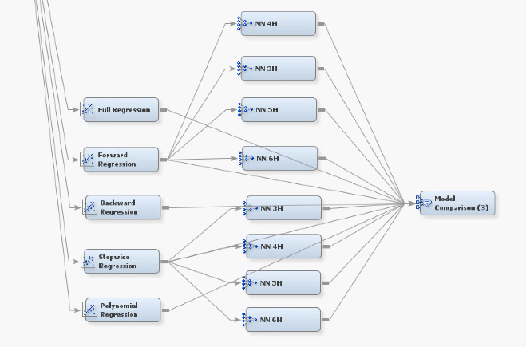

*** However, post consultation we decided to work with regressions which were derived from our treated data. Though the untreated data gave us better ASE in general across different model types, after careful consideration we proceeded with data which were more fit.

**Forward Regression Neural Network:**

In our project, we combined a neural network with forward regression and rigorously investigated the effectiveness of changing the number of hidden units and iterations. To determine the ideal setup, we gradually tested with 3 default units at first. We determined the point at which efficiency began to suffer by linking neural networks with various hidden units and tweaking iterations, establishing the ideal balance between complexity and performance.

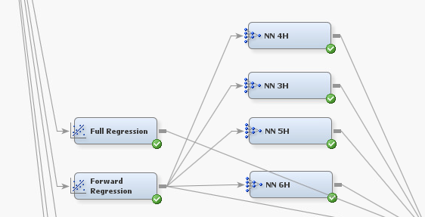

### 3 Hidden Unit Neural Networks

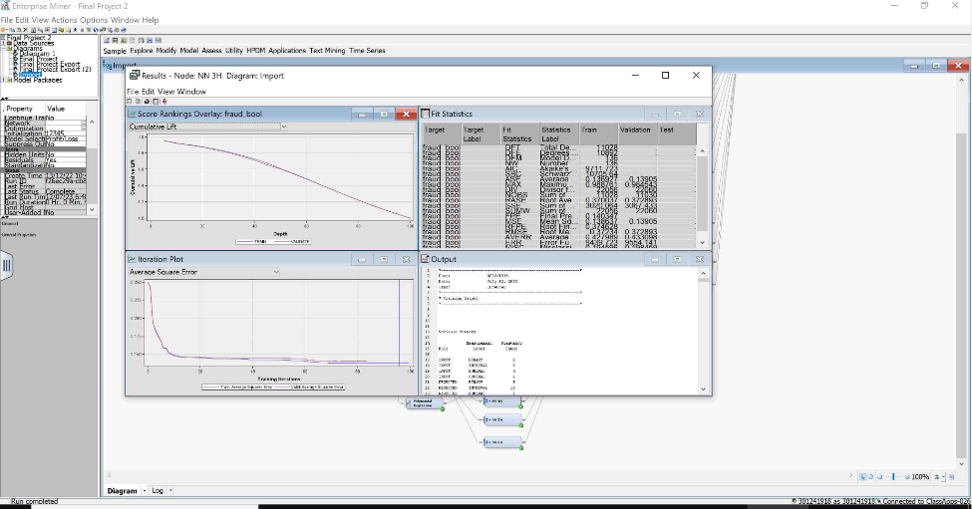

The average square error of a neural network with 3 hidden unit and 100 iterations is 0.13905, which is lowest in all Neural Networks.

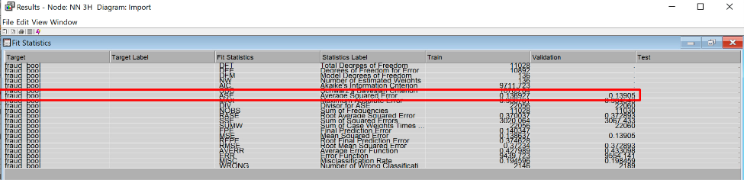

### 4 Hidden Unit Neural Networks

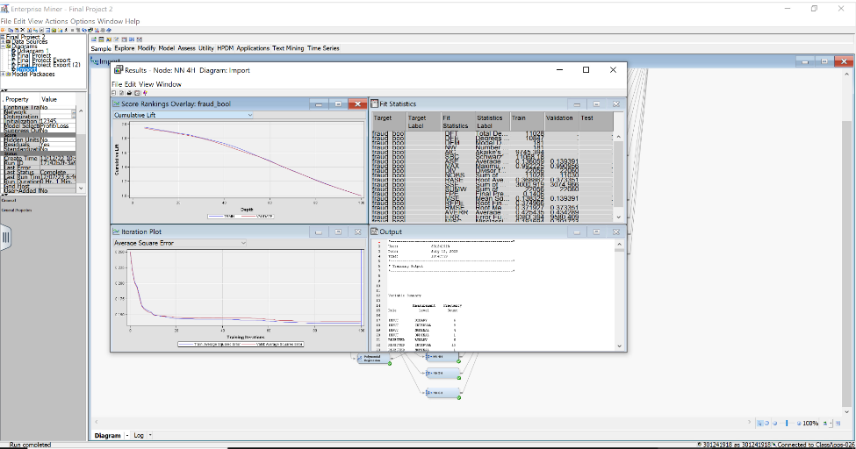

The average square error of a neural network with 4 hidden unit is 0.139391 with cut-off iterations at 100.

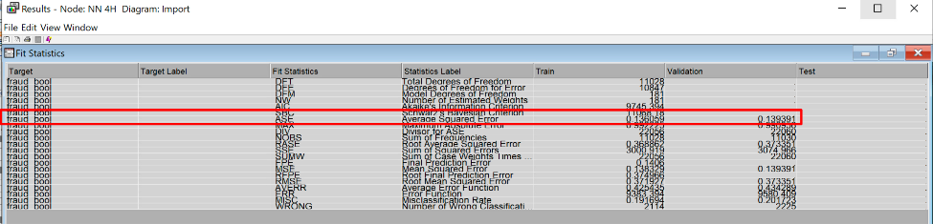

### 5 Hidden Unit Neural Networks

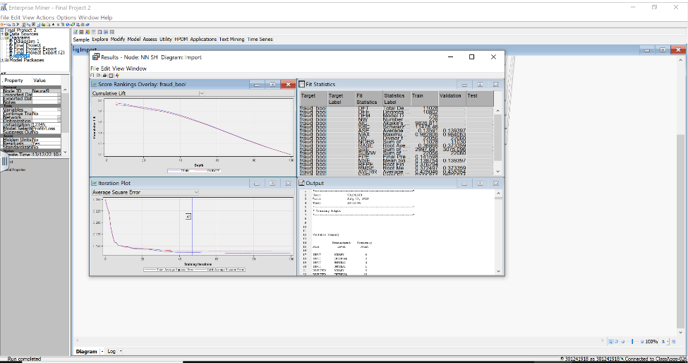

The average square error of a neural network with 5 hidden unit and 47 iterations is 0.139397

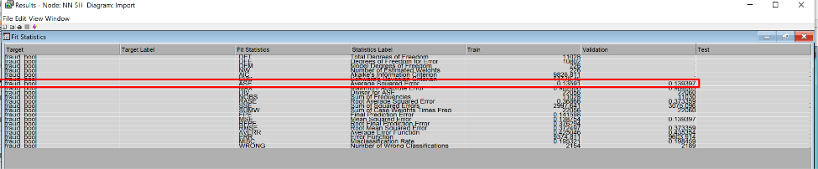

### 6 Hidden Unit Neural Networks

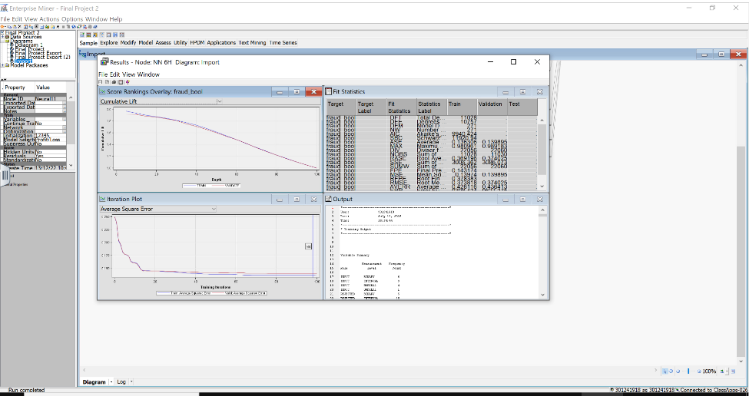

The average square error of a neural network with 6 hidden units is 0.139895 with cut-off iterations at 98. The Average Square Error is the highest, with 6 hidden units among all other neural networks.

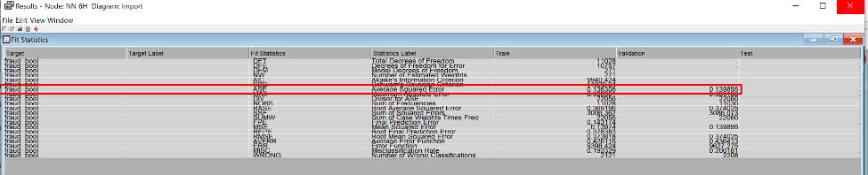

**Stepwise Regression Neural Network:**

We also explored the stepwise NN, to evaluate if the iterative process of adding and removing variables help the NN error scores or not.

### 3 Hidden Unit Neural Networks

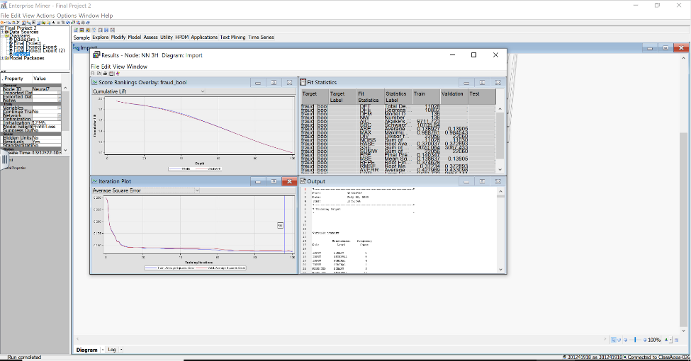

The average square error of a neural network with 3 hidden unit and 96 iterations is 0.13905, which is lowest in all Neural Networks.

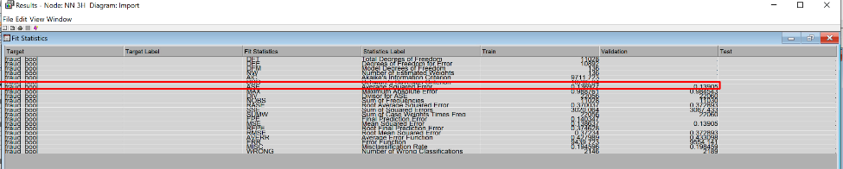

### 4 Hidden Unit Neural Networks

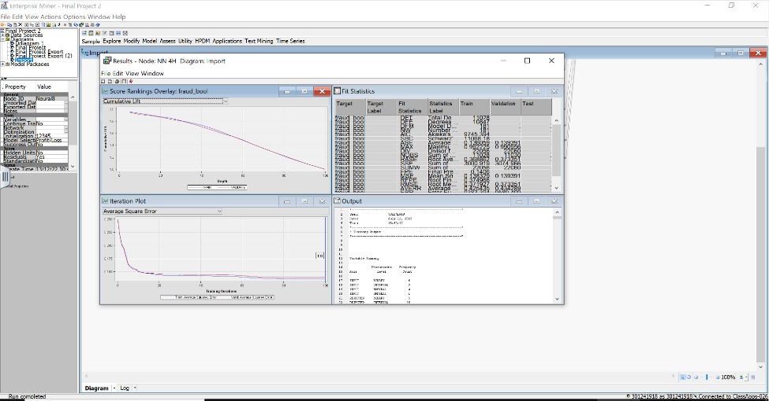

The average square error of a neural network with 4 hidden units is 0.139391 with cut-off iterations at 100.

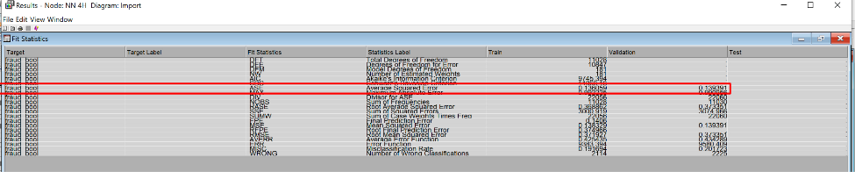

### 5 Hidden Unit Neural Networks

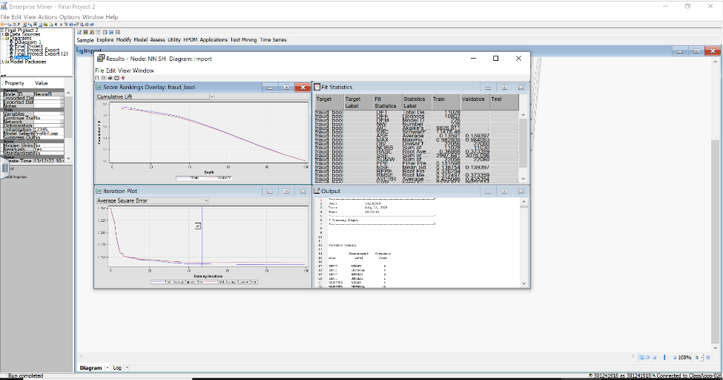

The average square error of a neural network with 5 hidden unit and 47 iterations is 0.139397

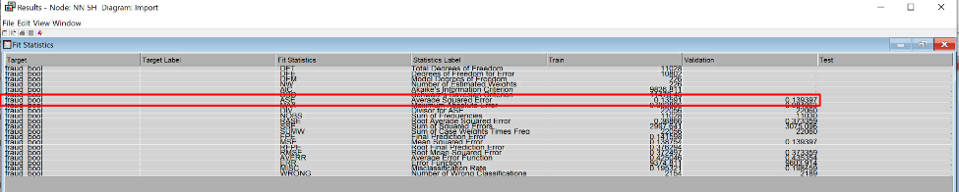

### 6 Hidden Unit Neural Networks

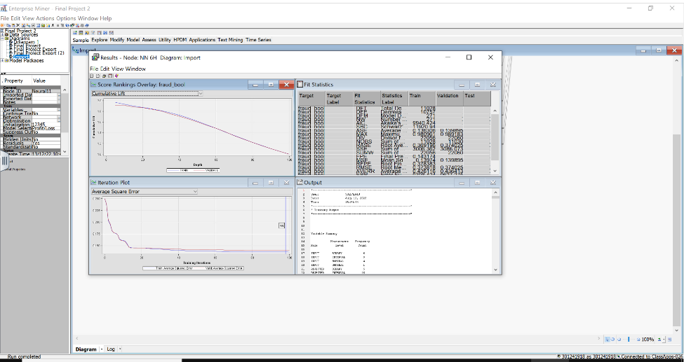

The average square error of a neural network with 6 hidden units is 0.139895 with cut-off iterations at 98. The Average Square Error is the highest, with 6 hidden units among all other neural networks.

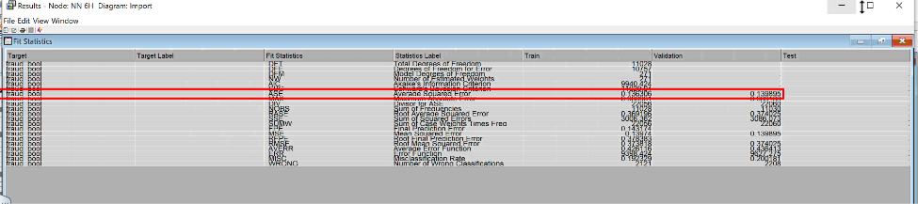

# Gradient Boosting

Gradient Boosting Models are one of the most popular ensemble techniques used in machine learning. Gradient Boosting works by combining many “weak learners” to create a stronger prediction model. Each weak learner focuses on a small part of the prediction, and looks to improve upon the mistakes of the previous weak learner.

For our project, we developed 2 gradient boosting models:

* Gradient Boosting 100
* Gradient Boosting 500
* Gradient Boosting 800

The screenshot of the two models are shown below:

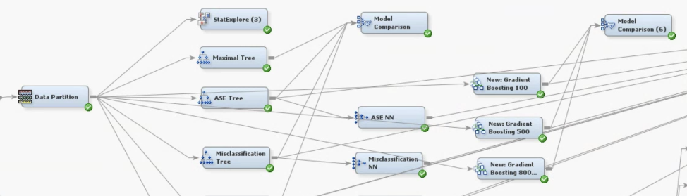

## Gradient Boosting 100

The first boosting model is the Gradient Boosting 100. This model was run for 100 iterations with the maximum branch and depth of each weak learner set to 2. The model achieved an Average Squared Error of **0.138853** and a misclassification rate of **0.196283.** The model achieved it’s lowest ASE after 93 iterations.

The results of the first boosting model is shown below:  
  
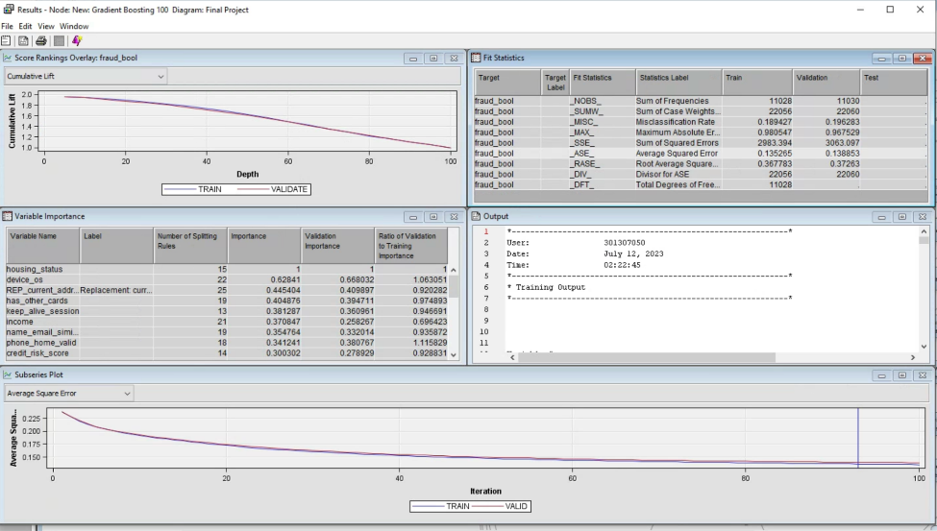

## Gradient Boosting 500

The second Gradient Boosting model was run for 500 iterations, to determine whether allowing the model to run for more iterations would lead to better training and predictions. All other hyper parameters were kept the same as the previous model. After 496 iterations, the Gradient Boosting 500 model achieved an Average Squared Error of **0.132888,** which is the lowest ASE among all the models developed. The misclassification rate was **0.187217.**

The results window of the Gradient Boosting 500 model is shown below:

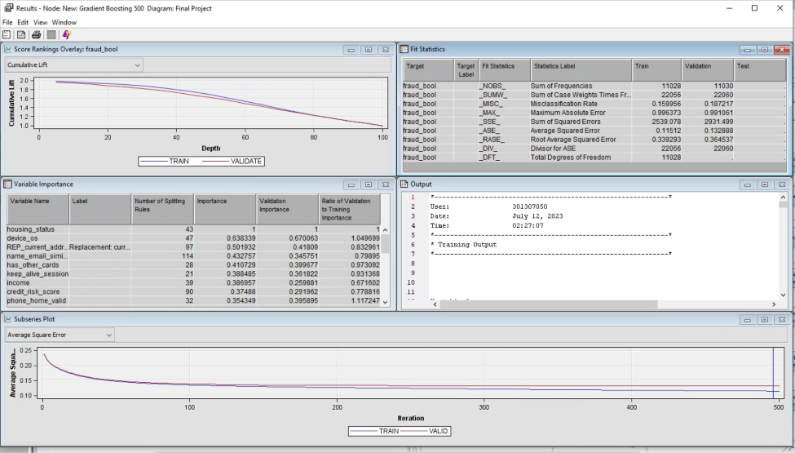

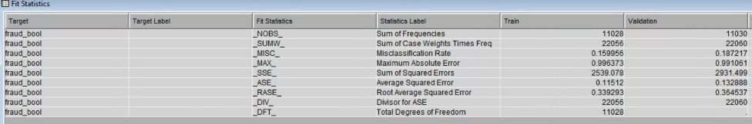

## Gradient Boosting 800

To determine whether allowing the model to run for even more iterations would result in better predictions, we built the Gradient Boosting 800 model, which was run for 800 iterations, still with max depth and branches set to 2.

However, the validation ASE and misclassification rate remains the same at **0.132888** and **0.187217,** indicating that additional iterations do not improve the model further. The results window of the Gradient Boosting 500 model is shown below:

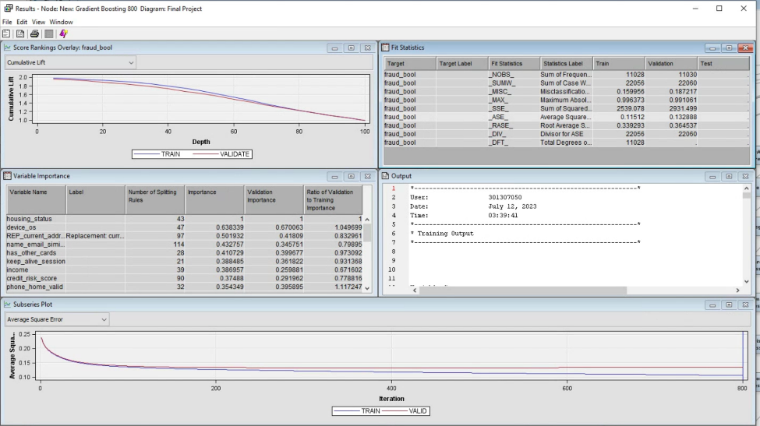

# Principal Component Analysis

Principal Component Analysis is a technique to simplify complex data by combining the variables in a dataset into combined features that explain the largest variation in the data, called Principal Components. PCA reduces the dimensionality of the data while retaining as much information about the features as possible. This reduces the curse of dimensionality and simplifies the data for further modeling.

For our project, we conducted PCA analysis to determine whether the models built from the principal components would have higher predictive accuracy. We added a Principal Component node after the oversampling node, and then partitioned the data into training and validation sets for modeling. The most important variables included in PCA 1 were Housing Status, Credit Risk Score, and Proposed Credit Limit. Screenshot of the nodes are shown below:

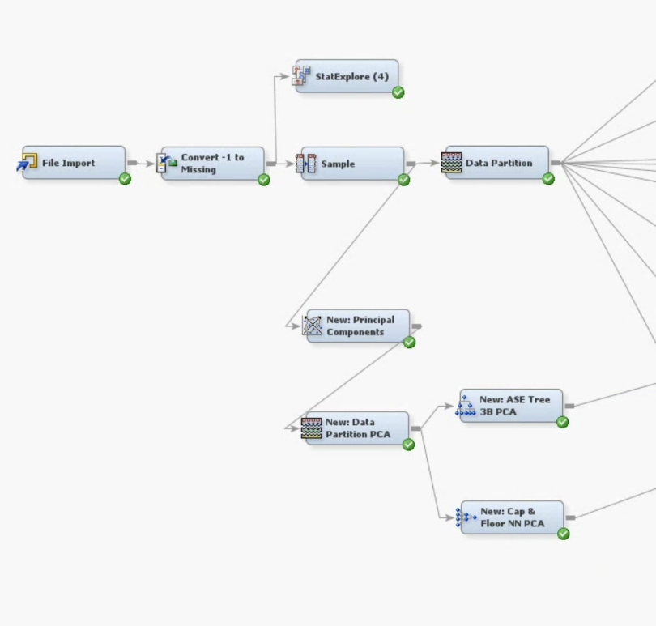

From the Principal Components, we developed two models:

* ASE Tree 3B PCA
* Cap & Floor NN PCA

These were our two best models developed before conducting PCA, and we wanted to determine whether conducting PCA would improve these models.

## ASE Tree 3B PCA

The first model - ASE Tree 3B PCA, achieved a validation ASE of **0.157839** and a misclassification rate of **0.221551.**

Results window shown below:

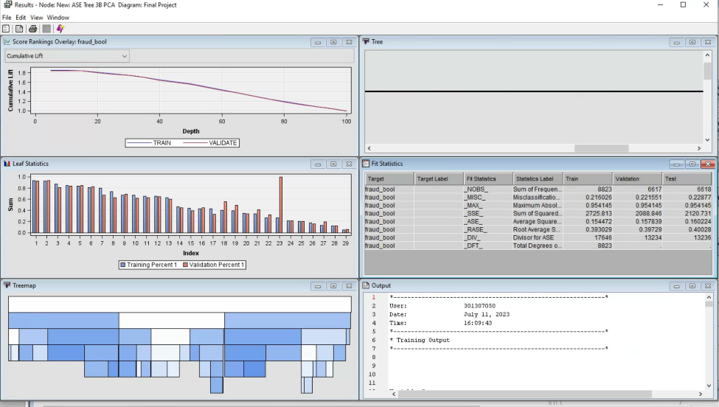

## Cap & Floor NN PCA

The Cap & Floor Neural Network was identified as one of the best models we developed, and therefore we wanted to find out whether a Neural Network with the same settings would be improved by the Principal Component Analysis. We attached the Neural Network to the PCA data partition node.

The Neural Network had an ASE of **0.146428** and a misclassification rate of **0.203113.** Results are shown below.

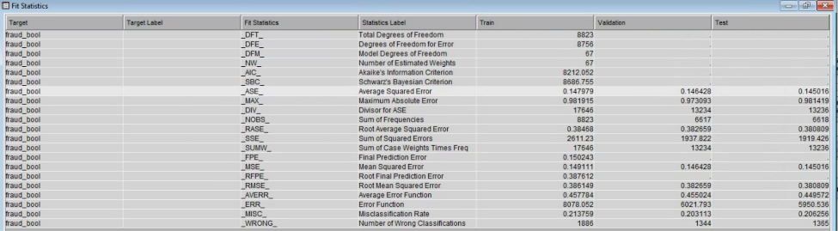

Overall, the predictive performance of the models were not improved by conducting PCA analysis, and in some cases, the performance decreased.

# Model Comparison

In order to devise the best model, we created 23+ different models which we ran throughout this entire project. The Model Comparison node in SAS Enterprise Miner helps us compare the statistics for all 23+ models in one panel. A screenshot of the summary statistics for each model is given below:

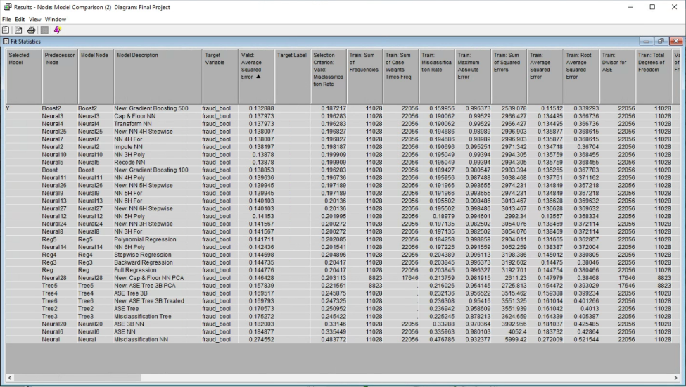

From the statistics we can come to the conclusion that Gradient Boosting 500 is the best model. It has the lowest Average Squared Error at **0.132888** and **0.187217** Misclassification Rate. Cap and Floor was the second modification in all the data modifications we have done. None of the skews were adjusted in this model. However it is important to note that the boosting models were developed before treating the data - cap & floor, adjusting skews, etc. Despite the lack of data adjustments, the Gradient Boosting 500 is the best model.

Using the ROC index and Gini coefficient from the screenshot below, we confirm that Gradient Boosting 500 is indeed the best model. The highest ROC and Gini are preferred. Cap and Floor NN have a ROC index of 0.883 and a Gini coefficient of 0.766. Gradient Boosting 500 has an ROC index of **0.892** and a Gini coefficient of **0.783.**.

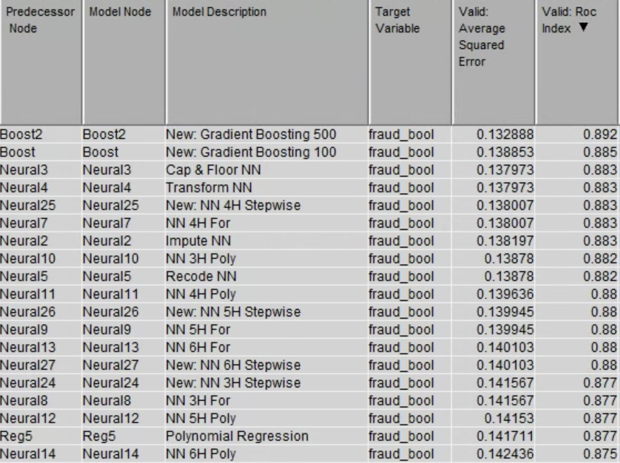

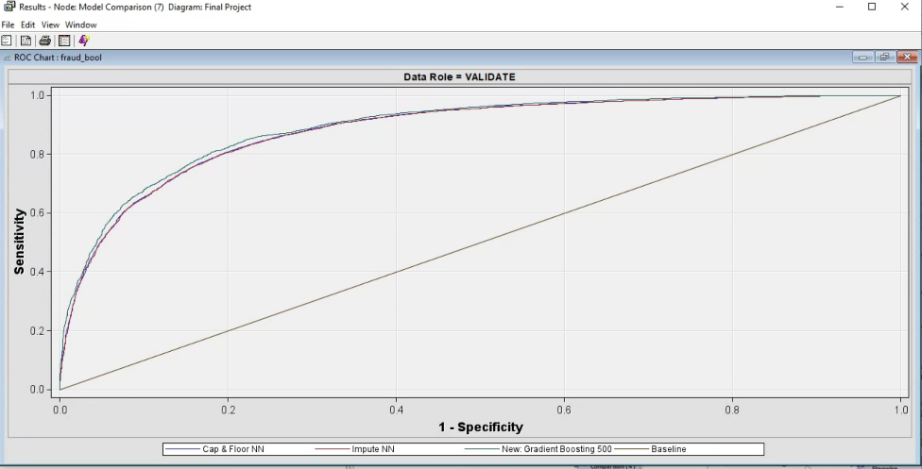

As seen in the picture above, the Gradient Boosting 500 mode has the largest area under the ROC curve, compared to the other best models - the Cap & Floor and Impute Neural Networks, especially at lower levels of specificity. Also, Cap & Floor NN and Impute NN have the exact same ROC curve across all levels of specificity. It is difficult to make any distinction between the two. However, their error rates are different only by 0.000224 (0.138197-0.137973). Though negligible in most scenarios, in the case of modeling lower error rate gets higher priority.

Neural Networks(NN) have their own logic in deriving the best model, and one of the biggest disadvantages of these types of models is that the interpretation of data is next to impossible.

However, we can analyze the fundamentals of this model to get an idea as to why we received the best model without significant modification of the dataset. Through all the adjustments made in our model, we were trying to fit our model. The more we tried to fit, the further we strayed from the truth of the dataset. Neural Network is a robust model mechanism that can work with all variables to create a relation. In this case, NN turned out to be the best model to use.

As a matter of fact, outside of the boosting models, all the other top models are NNs. The 2nd best is Impute NN which we discussed. The 3rd best model is a 3-hidden unit NN attached to a Forward regression with an ASE of 0.139412 and a Misclassification rate of 0.197915.

# 

# Recommendations and Key Findings

## Models to Use

Upon evaluating the performance of all the models, we have determined that the Gradient Boosting 500 model is the most accurate at predicting fraudulent bank account applications. This was determined by evaluating average squared error, the ROC index, and Gini coefficient. We recommend that the bank implement the Gradient Boosting 500 model to identify and flag potentially fraudulent account applications.

## Key Features

The following table outlines some of the selected key features that were identified to be important for predicting fraudulent applications by three models of varying types: 3 Branch Decision Tree, Forward Logistic Regression, and Cap and Floor Neural Network.

|  |  |  |
| --- | --- | --- |
| **Decision Tree** | **Logistic Regression Odds Ratios** | **Neural Network Weights** |
| Housing Status | Device Distinct Emails | Current Address Months Count |
| Device OS | Has Other Cards | Velocity_4w |
| Has Other Cards | Device OS | Device Distinct Emails |
| Keep Alive Session | Keep Alive Session |  |
|  | Housing Status |  |
|  | Payment Type |  |

## Features to monitor

Based on our analysis, the key features that seem to be the most predictive of bank account fraud are housing status, device OS, whether the applicant has other cards, keep alive session, and payment type. Our models, including decision trees, logistic regressions, and neural networks, all identified these variables as predictors of fraud. Additionally, our neural network weights and decision tree splits suggest that current address months count, Velocity_4w, and Device Distinct Emails are also important in predicting fraud.

Applications that are most likely to be fraudulent are ones where the applicant does not have any other cards with the bank and has not been living in their current address for very long, with a current housing status of BA. Additional indicators are the applicant paying by payment type AC and choosing not to keep the browser session alive on logout. A high number of applications using different email addresses from the same device, and submitted at a time with a high velocity of applications are also more likely to be fraudulent.

The presence of these features increases the likelihood of an application being fraudulent. As such, banks should scrutinize such applications that contain any or all of these features during the account approval process in order to flag potentially fraudulent account applications for further investigation.

Finally, since the dataset contains anonymized values which cannot be interpreted without knowing their meaning, such as payment type, housing status, and employment status etc. It is recommended that the bank investigate the anonymized values to gain a clearer understanding of the features of fraudulent applications. Understanding the meaning of these variables and how they can be used to identify fraudulent applications may help banks more effectively detect and prevent fraud.

# Conclusion

In conclusion, our project aimed to identify key features of fraudulent bank account applications and to train machine learning models that can accurately predict fraudulent applications. After oversampling, data partition, and treating the missing and skewed data, we trained decision trees, logistic regressions, gradient boosting, and neural network models to predict fraudulent applications.

The result of our modeling showed that housing status, device OS, device distinct emails, and presence of other cards were key variables in predicting fraudulent applications. Based on our findings, we recommend that the bank consider the identified key features when evaluating new account applications, and use the Gradient Boosting 500 model for most accurate predictions. By implementing these recommendations, the bank will be better equipped to identify and prevent fraudulent account openings.

# References

1. *5 types of bank account fraud – and how to prevent them*. SEON. (2022, December 7). Retrieved December 15, 2022, from https://seon.io/resources/bank-account-fraud/
2. *New account fraud*. OneSpan. (n.d.). Retrieved December 18, 2022, from https://www.onespan.com/topics/new-account-fraud

# Appendix

## Full Model Screenshot

# 